Project Gamming Database

Jaykumar Suthar

Mar 24, 2024

/*

** Author: Jaykumar Suthar

** Course: IFT/530

** SQL Server Version: Microsoft Azure SQL Edge Developer (RTM) - 15.0.2000.1574 (ARM64)

** Jan 25 2023 10:36:08 Copyright (C) 2019 Microsoft Corporation Linux (Ubuntu 18.04.6 LTS aarch64) <ARM64>

**

** Project History

** Date Created Comments

**

** 04/24/2024 Create Database

** 04/24/2024 Create Tables

** 04/24/2024 Populate Tables

** 04/24/2024 View Populated Tables

** 04/24/2024 Create View

** 04/24/2024 Check the View

** 04/24/2024 Create The Audit Table

** 04/24/2024 Create Trigger

** 04/24/2024 Check the GameAudit table with Insert-Update-Delete Queries

** 04/24/2024 Create Stored Procedures

** 04/24/2024 Check Stored Procedures

** 04/24/2024 Create User Define Function

** 04/24/2024 Check User Define Function

** 04/24/2024 Create Cursor

**

*/

**Project Screenshots : Gaming Database**

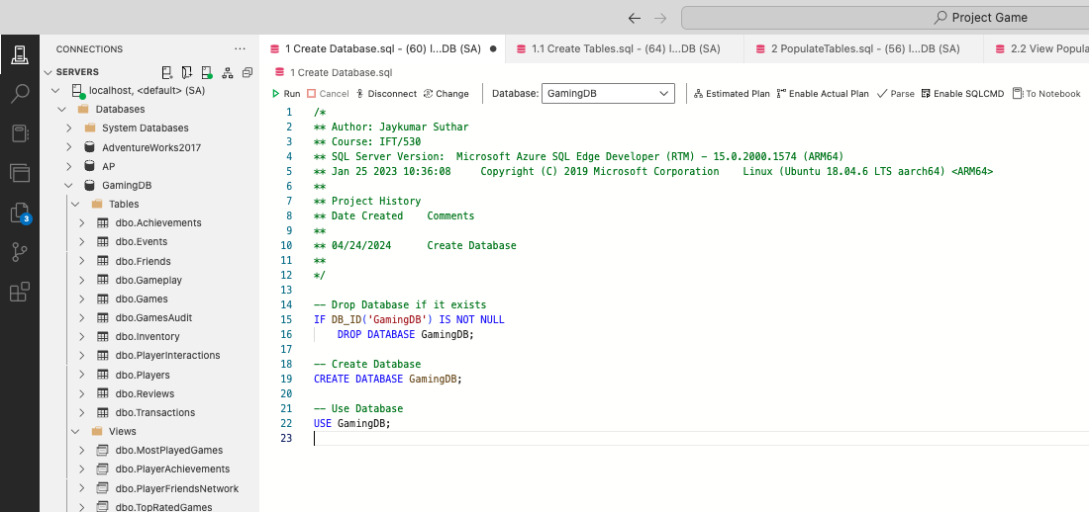Fig: 1 Create Database

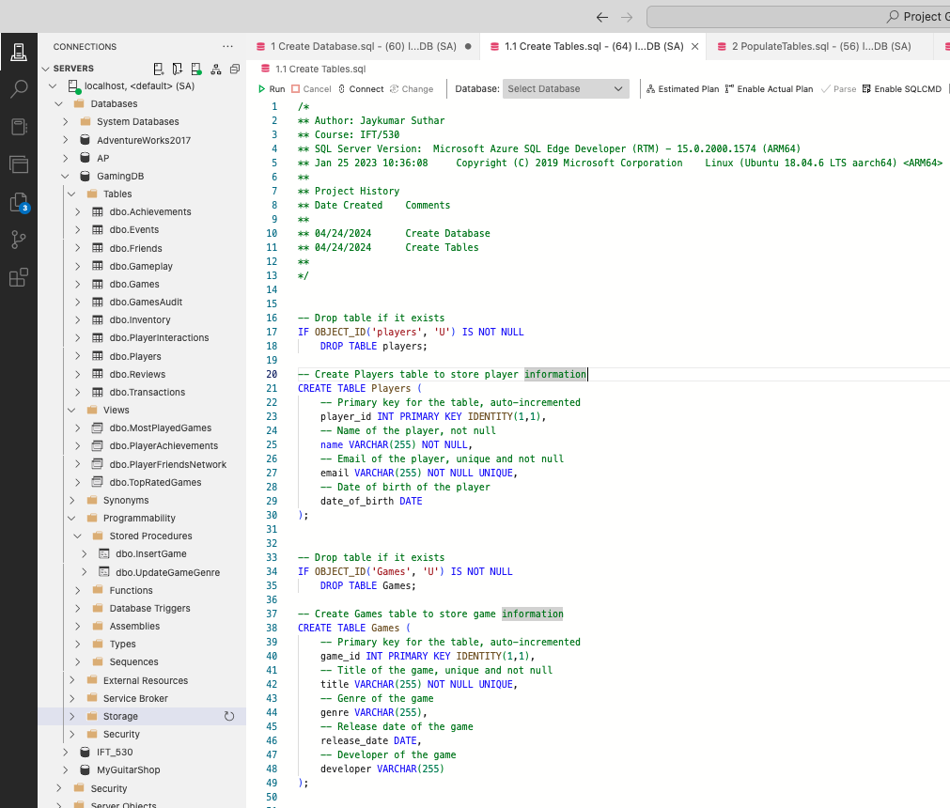 Fig: 2 Create tables

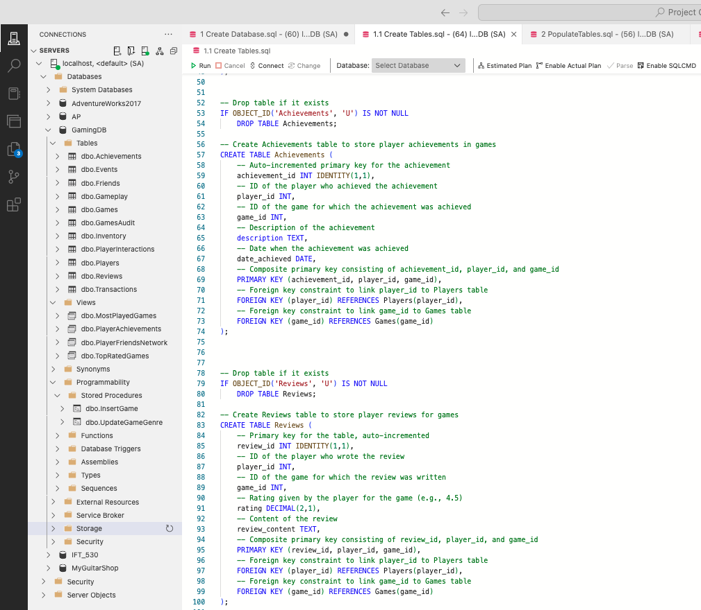 Fig: 2.1 Create tables Cont.1

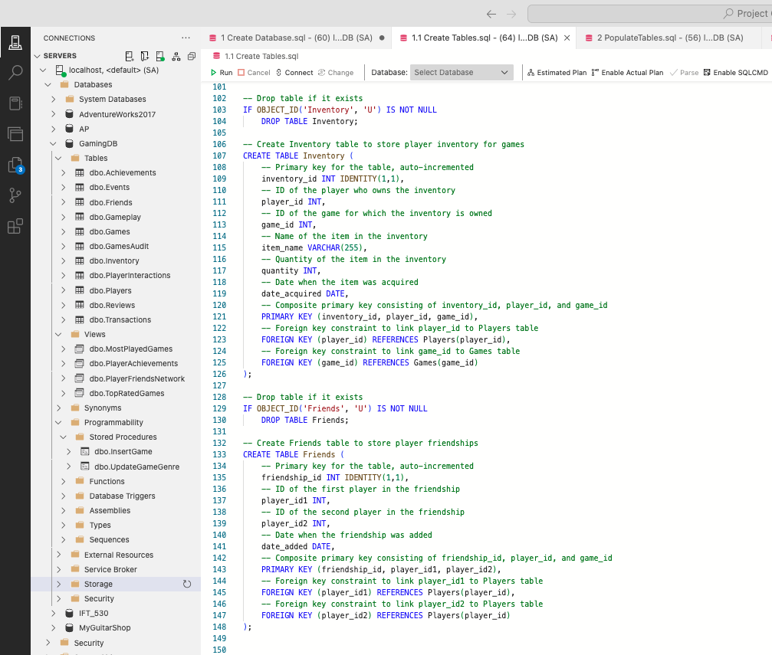 Fig: 2.2 Create tables Cont.2

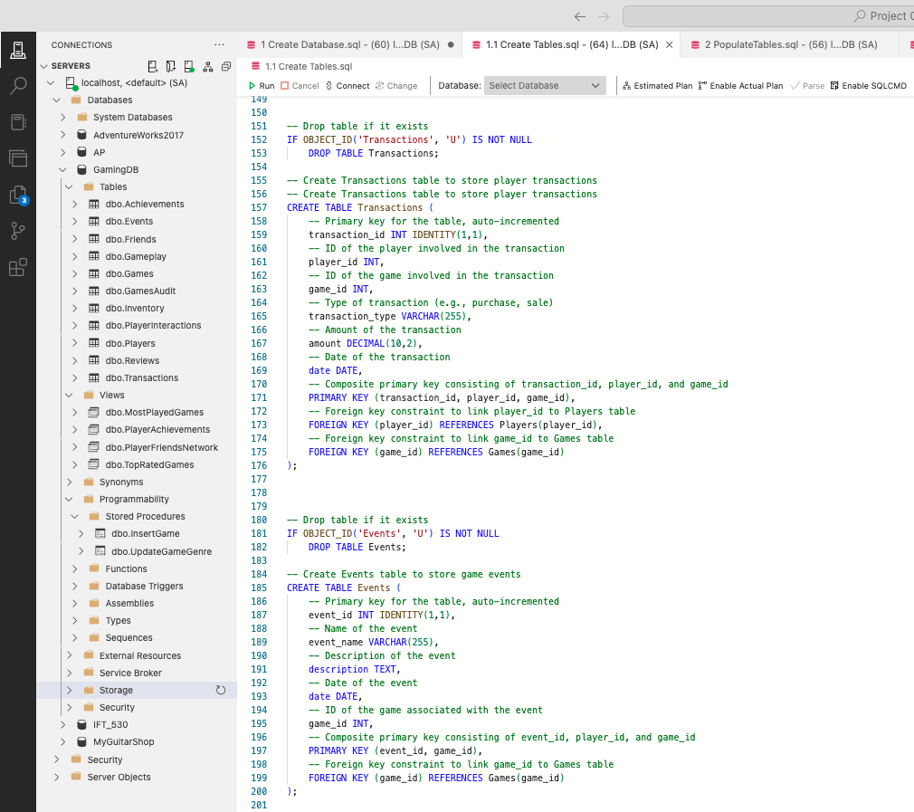

Fig: 2.3 Create tables Cont.3

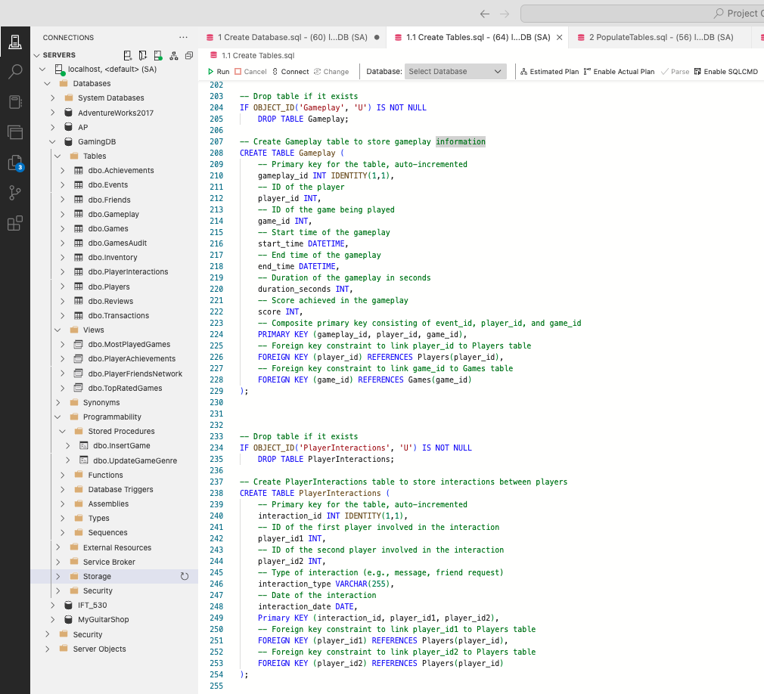

Fig: 2.4 Create tables Cont.4

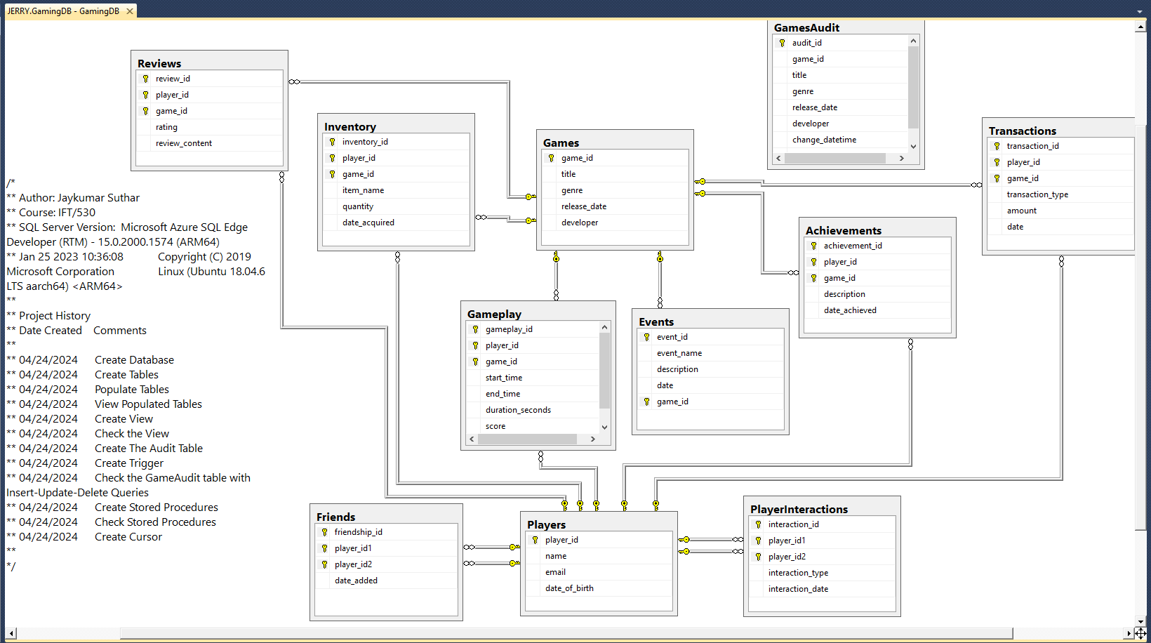

Fig: 2.4 Tables ER Diagram

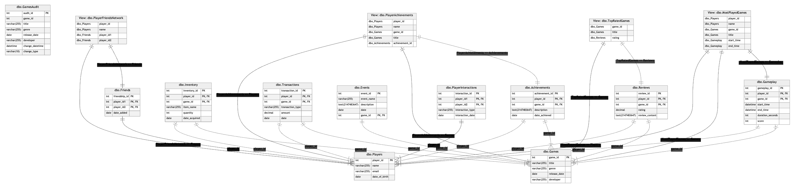 Fig: 2.5 Database Schema

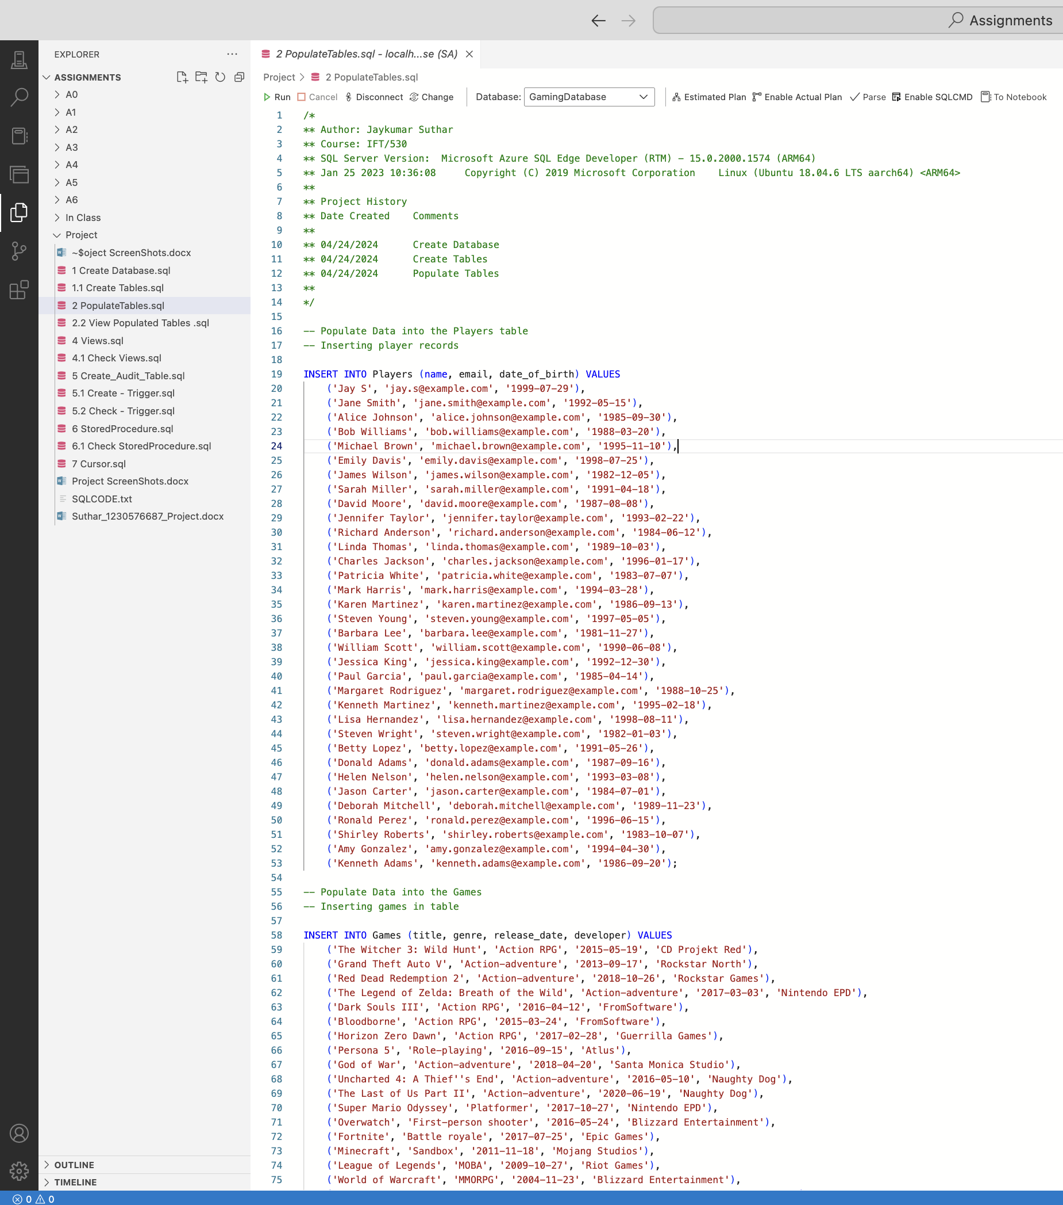 Fig: 3 populate tables

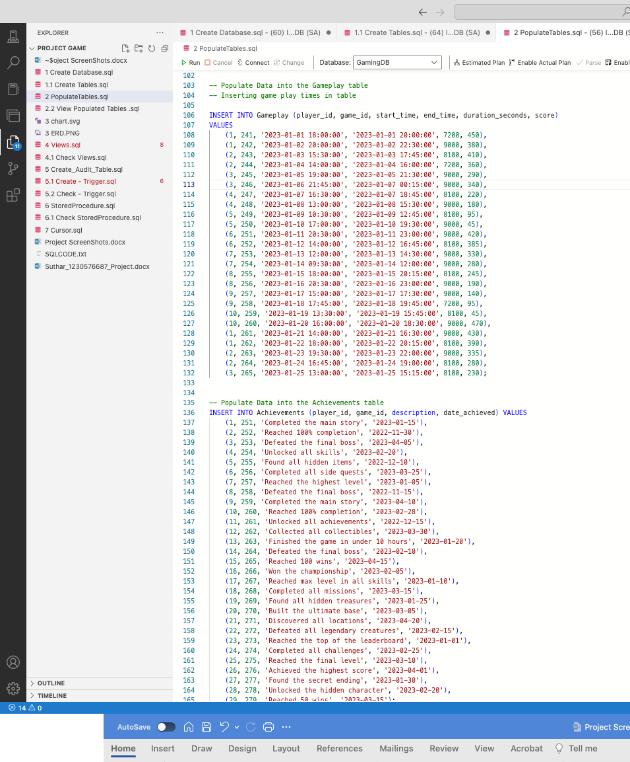

Fig: 3.1 populate tables Cont.1

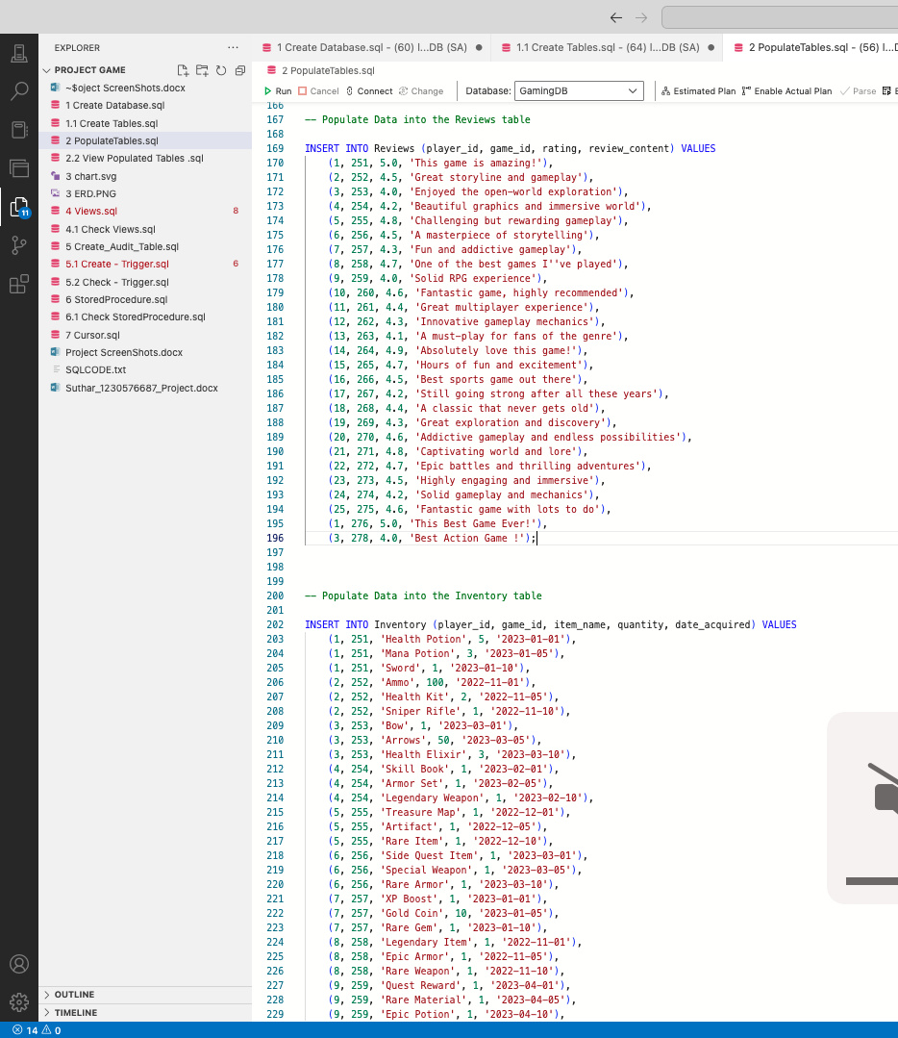

Fig: 3.2 populate tables Cont.2

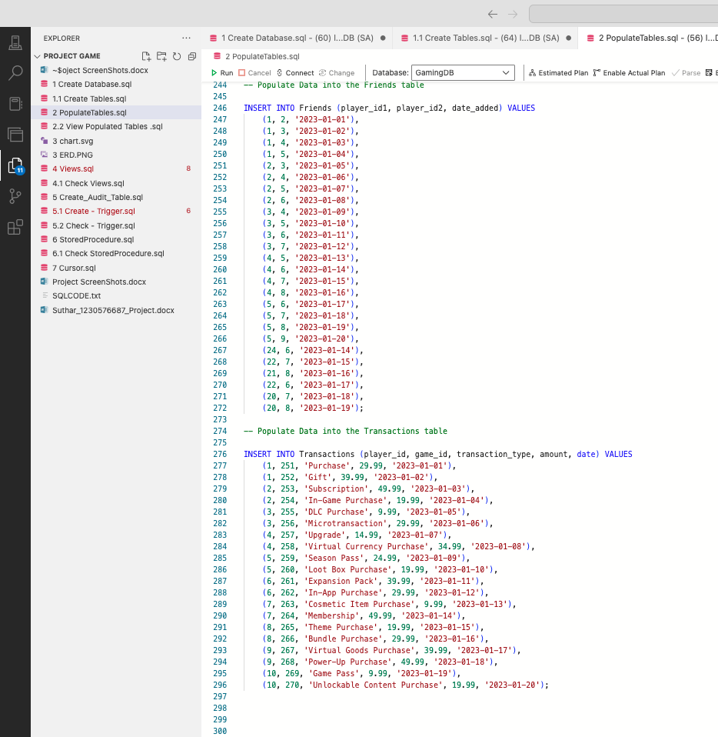 Fig: 3.3 populate tables Cont.3

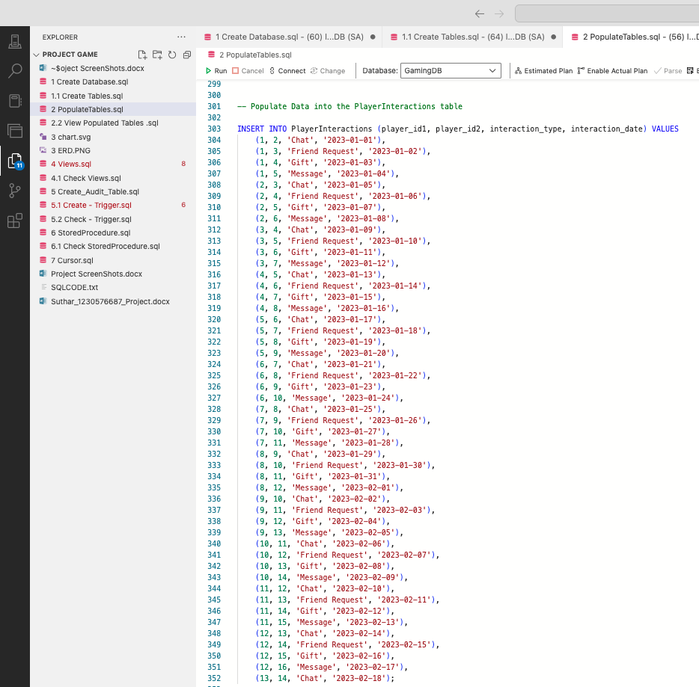

Fig: 3.4 populate tables Cont.4

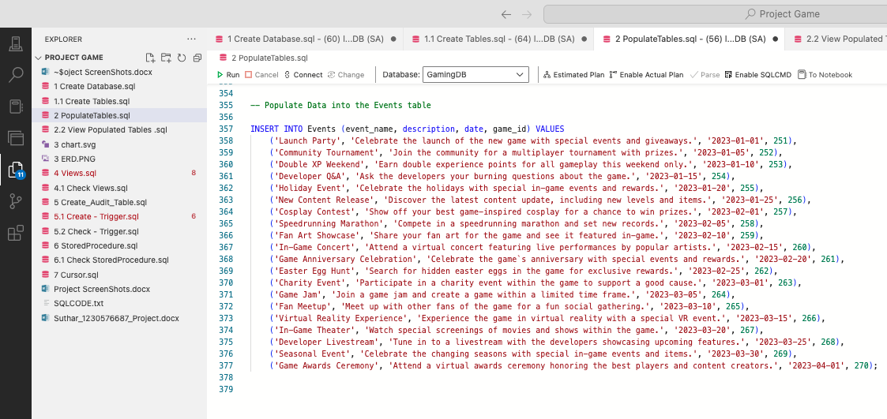

Fig: 3.4 populate tables Cont. 5

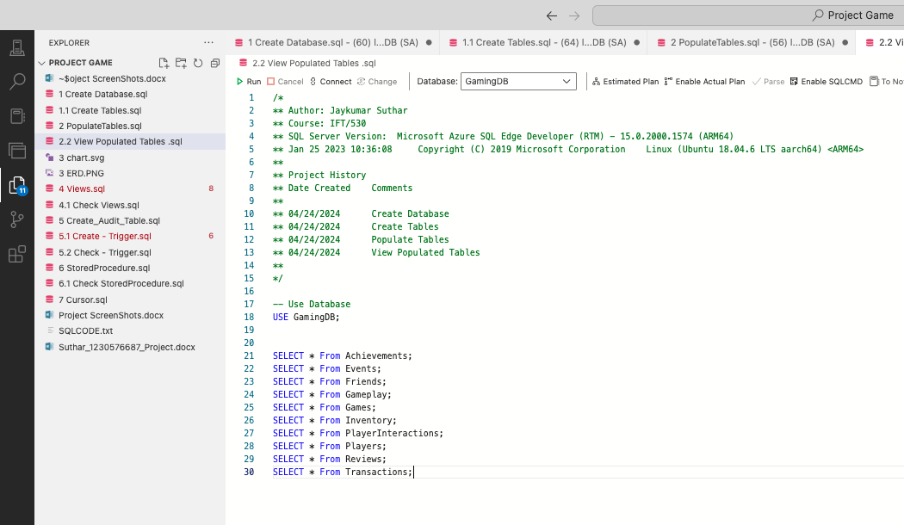 Fig: 4 Show tables

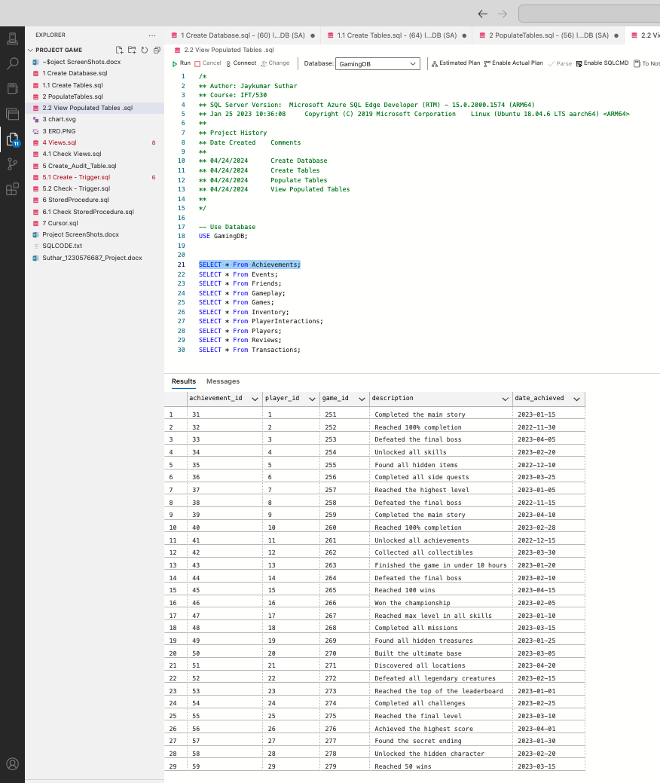 Fig: 5 Show Achievements

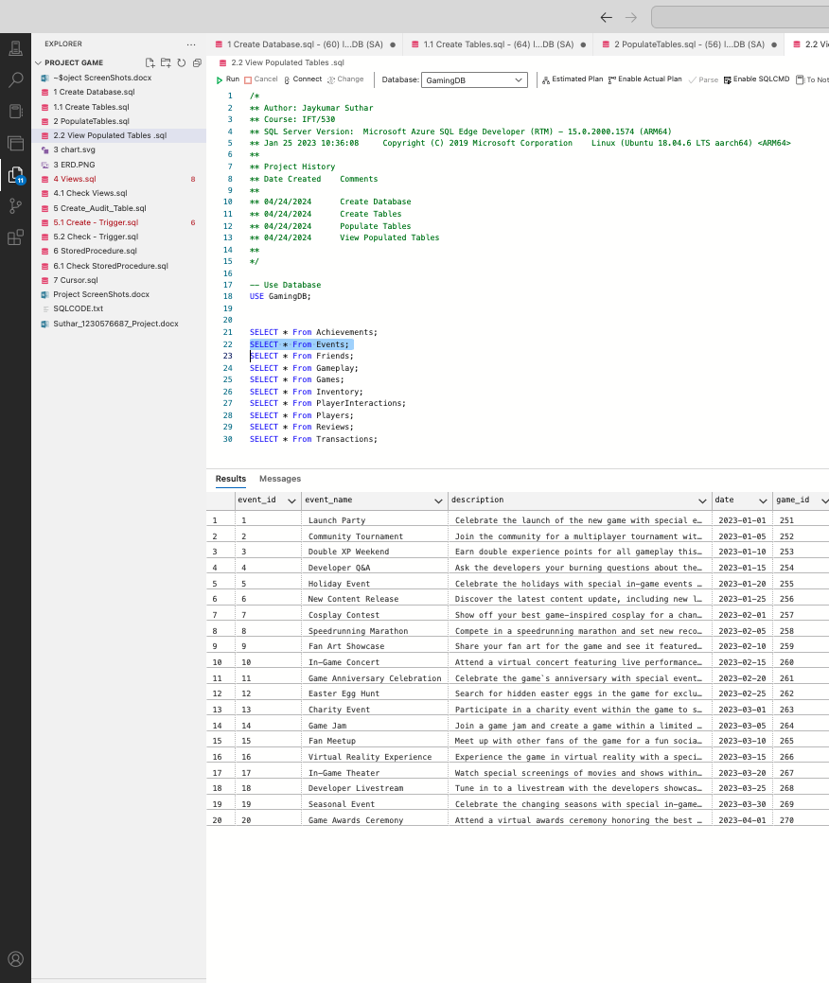 Fig: 6 Show Events

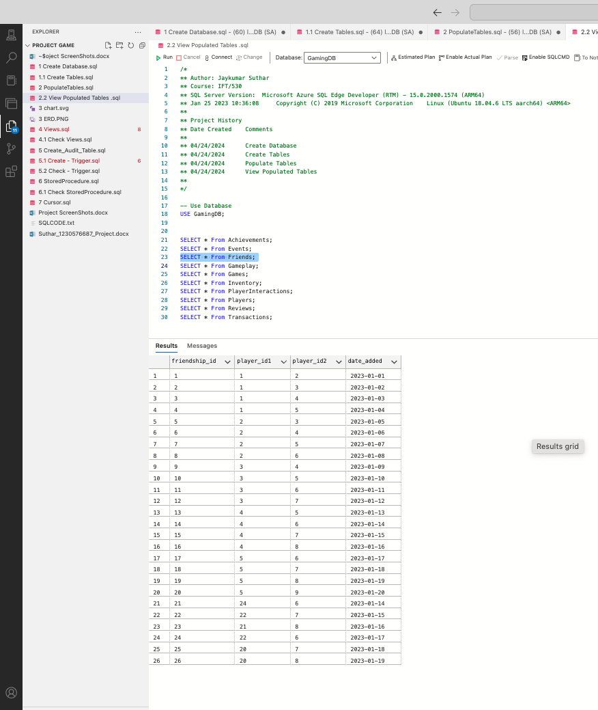 Fig: 7 Show Friends

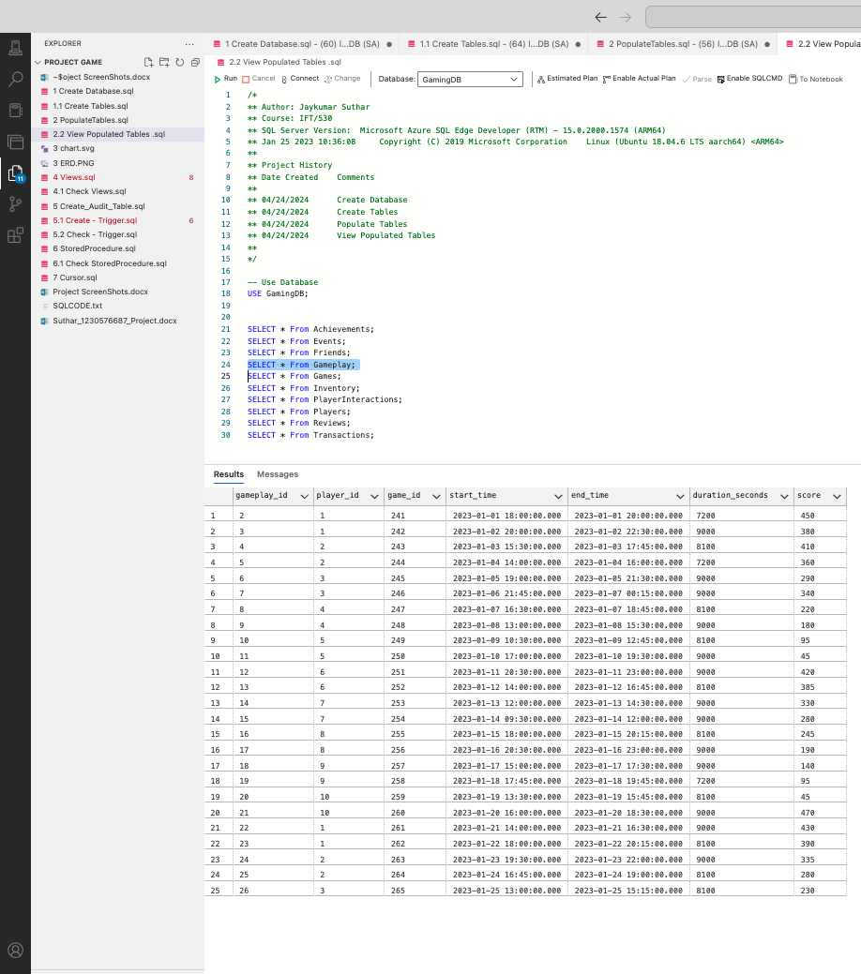 Fig: 8 Show Gameplay

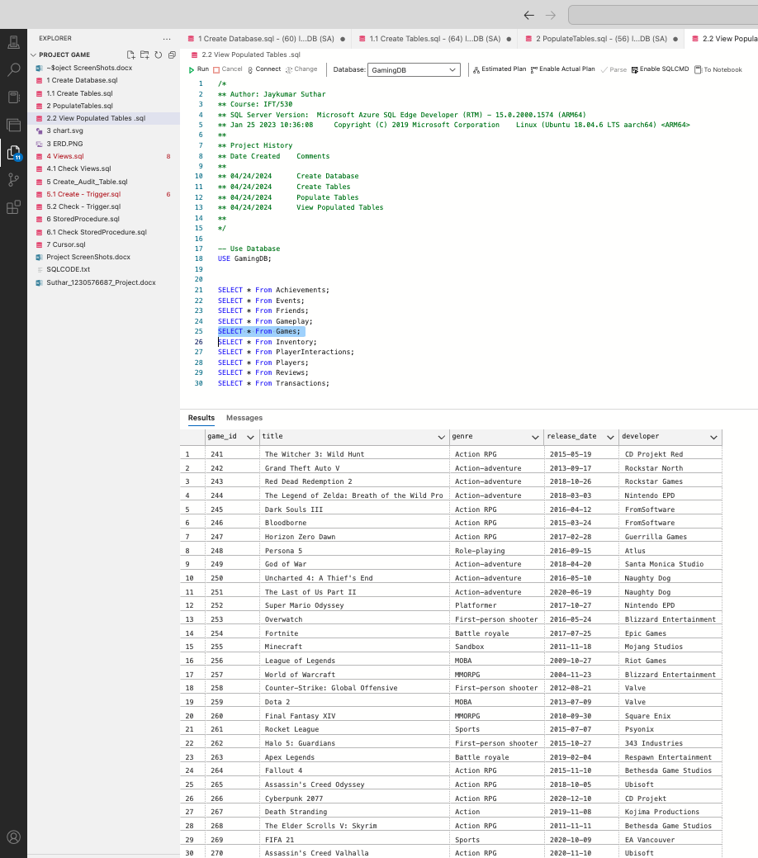 Fig: 9 Show Games

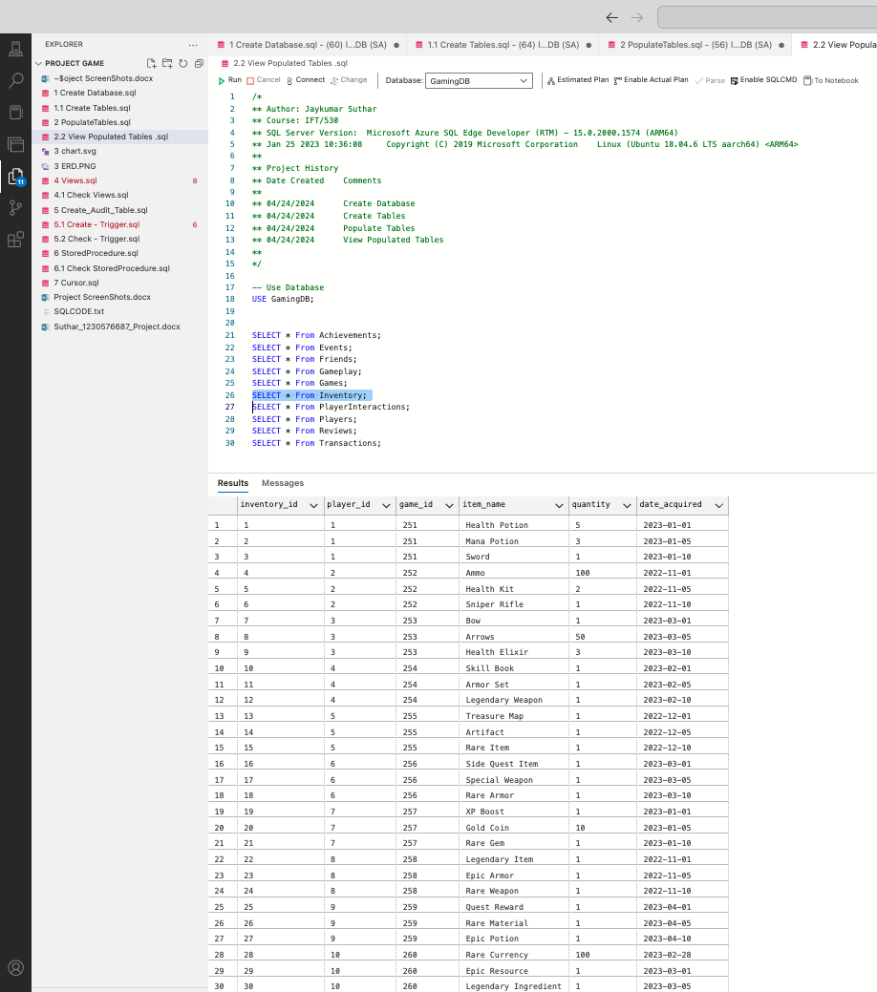 Fig: 10 Show Inventory

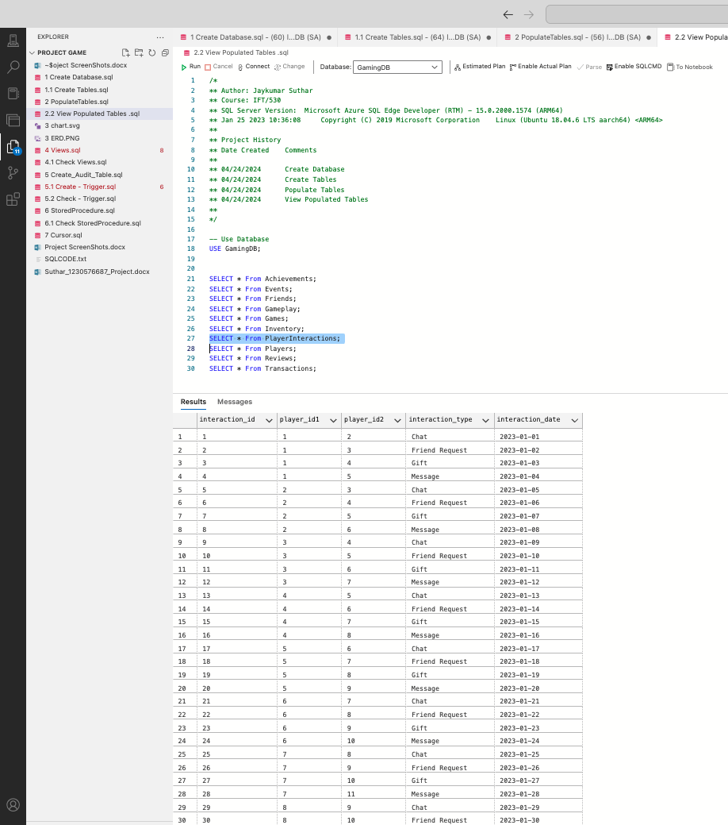 Fig: 11 Show Player Interactions

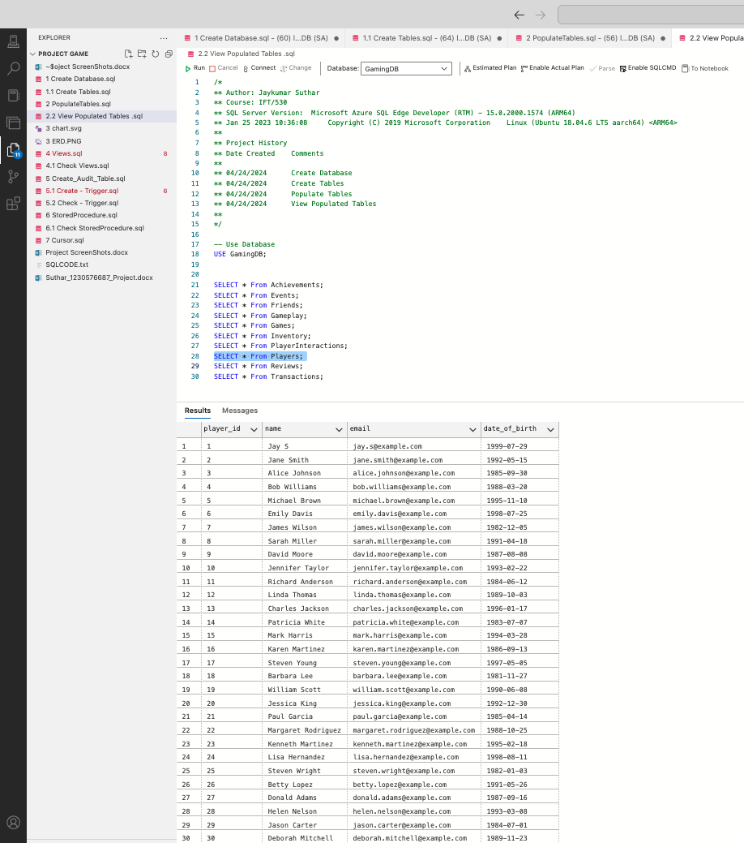 Fig: 12 Show Players

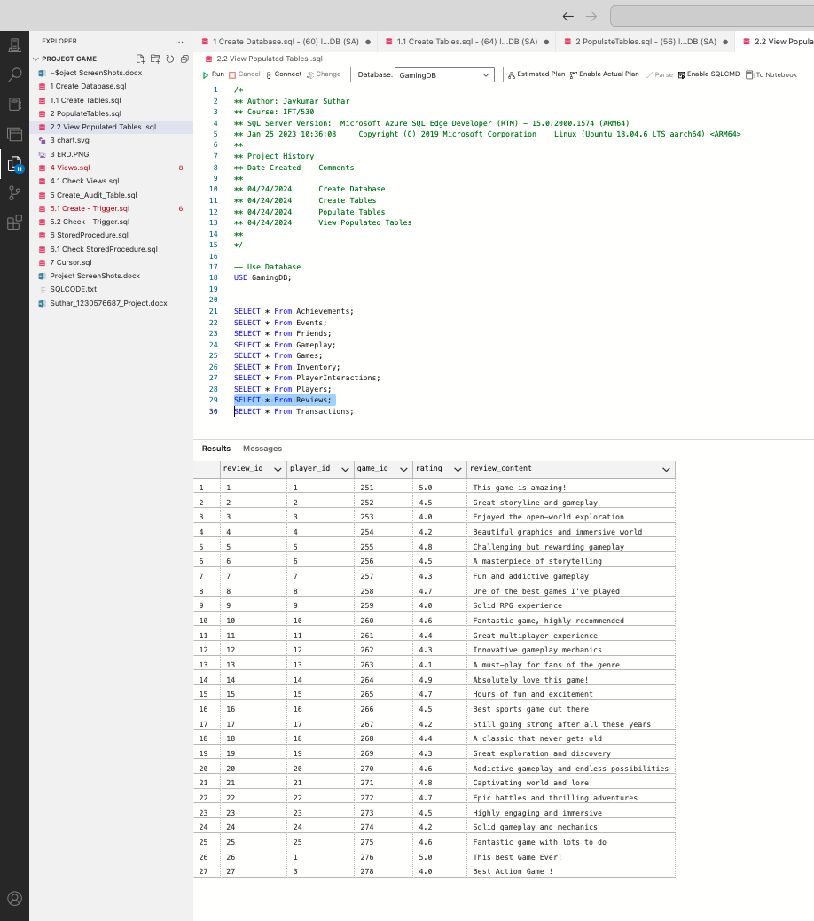 Fig: 13 Show Reviews

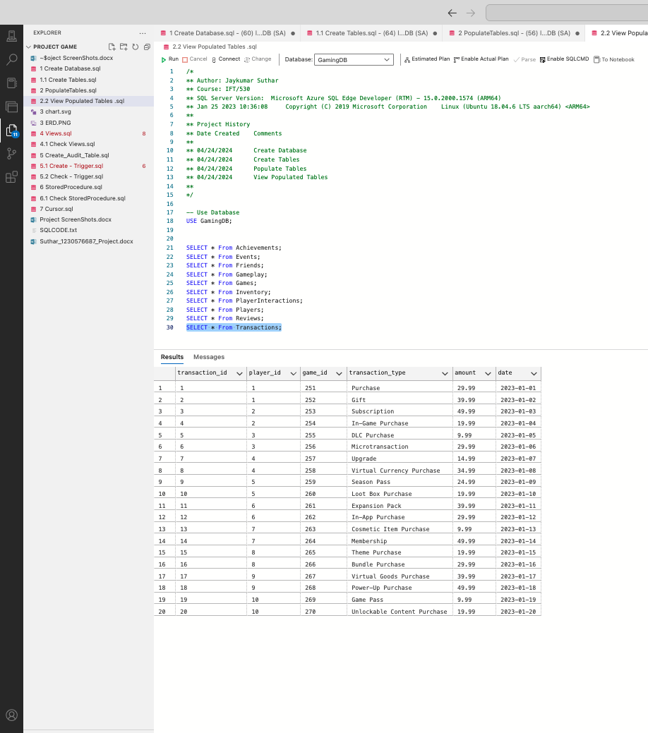 Fig: 14 Show Transactions

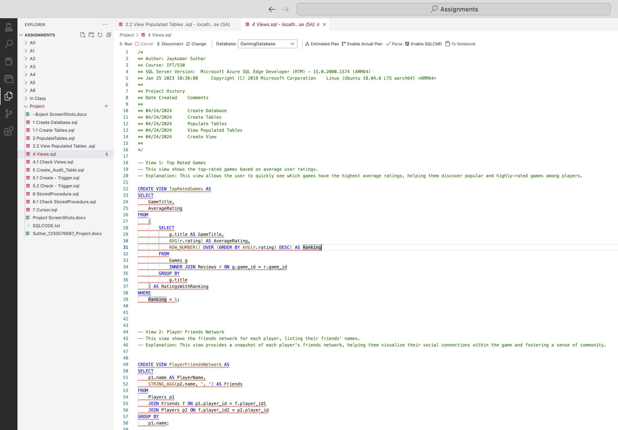 Fig: 15 Create Views

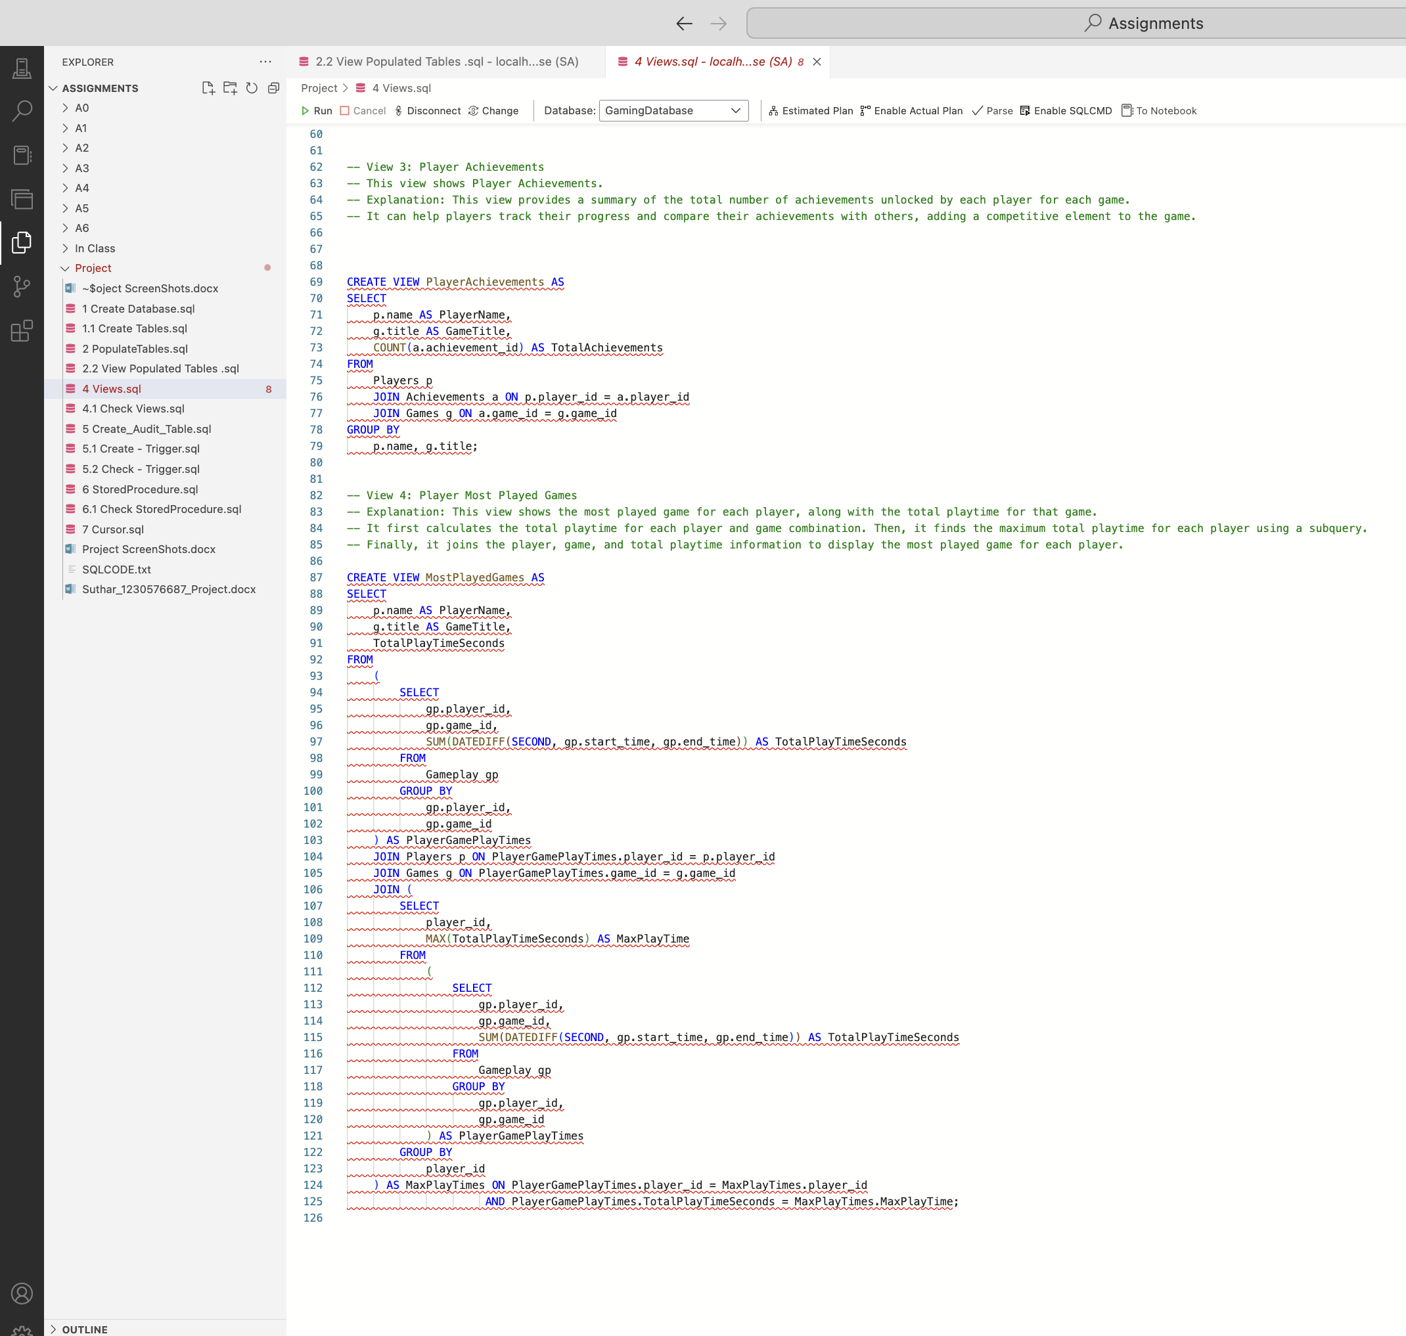Fig: 15.1 Create Views cont.1

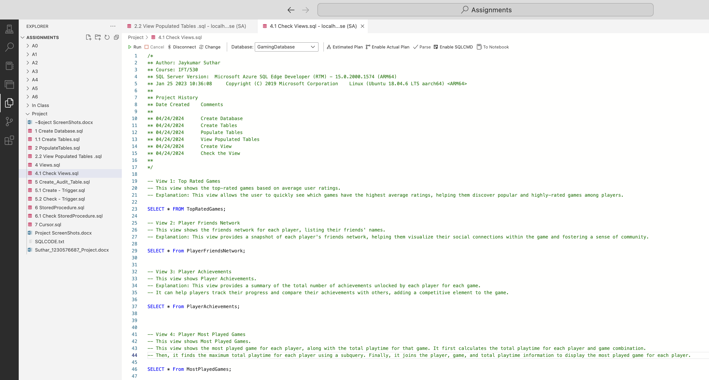 Fig: 16 Check Views

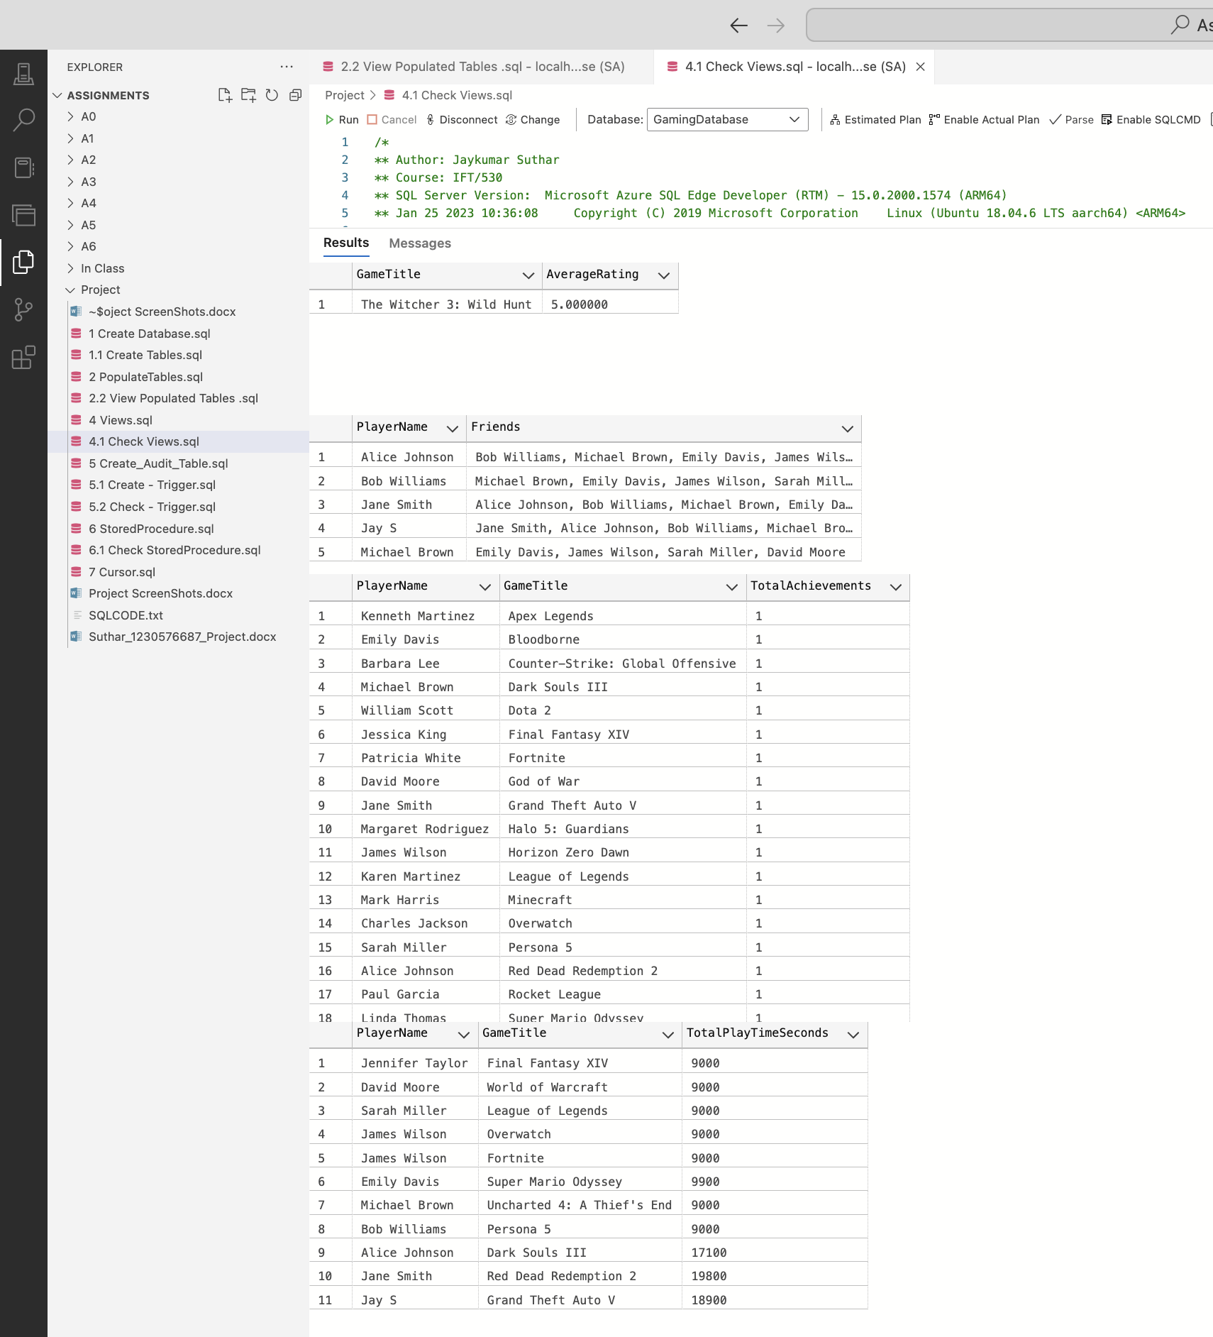 Fig: 16.1 Check Views Output

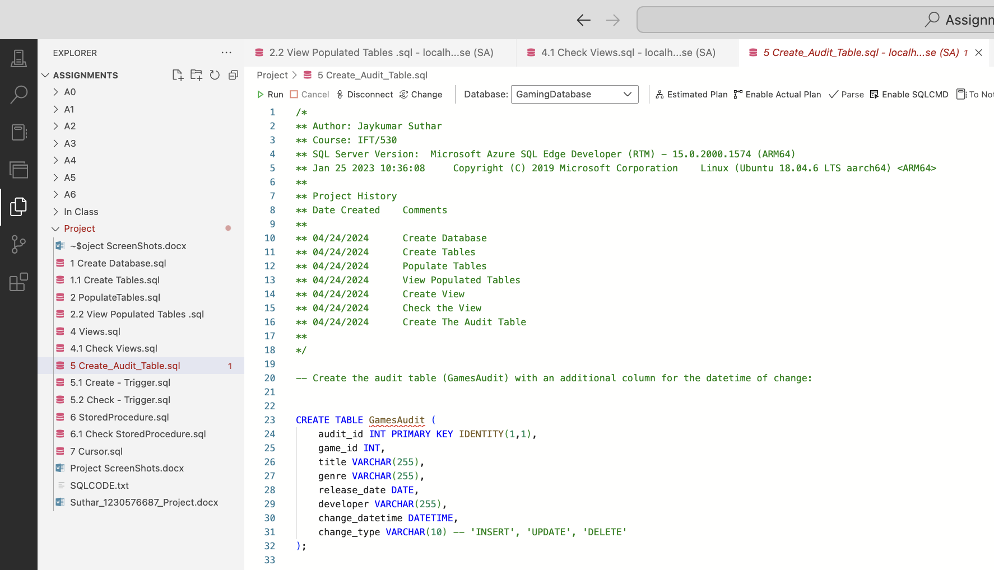 Fig: 17 Create Audit table

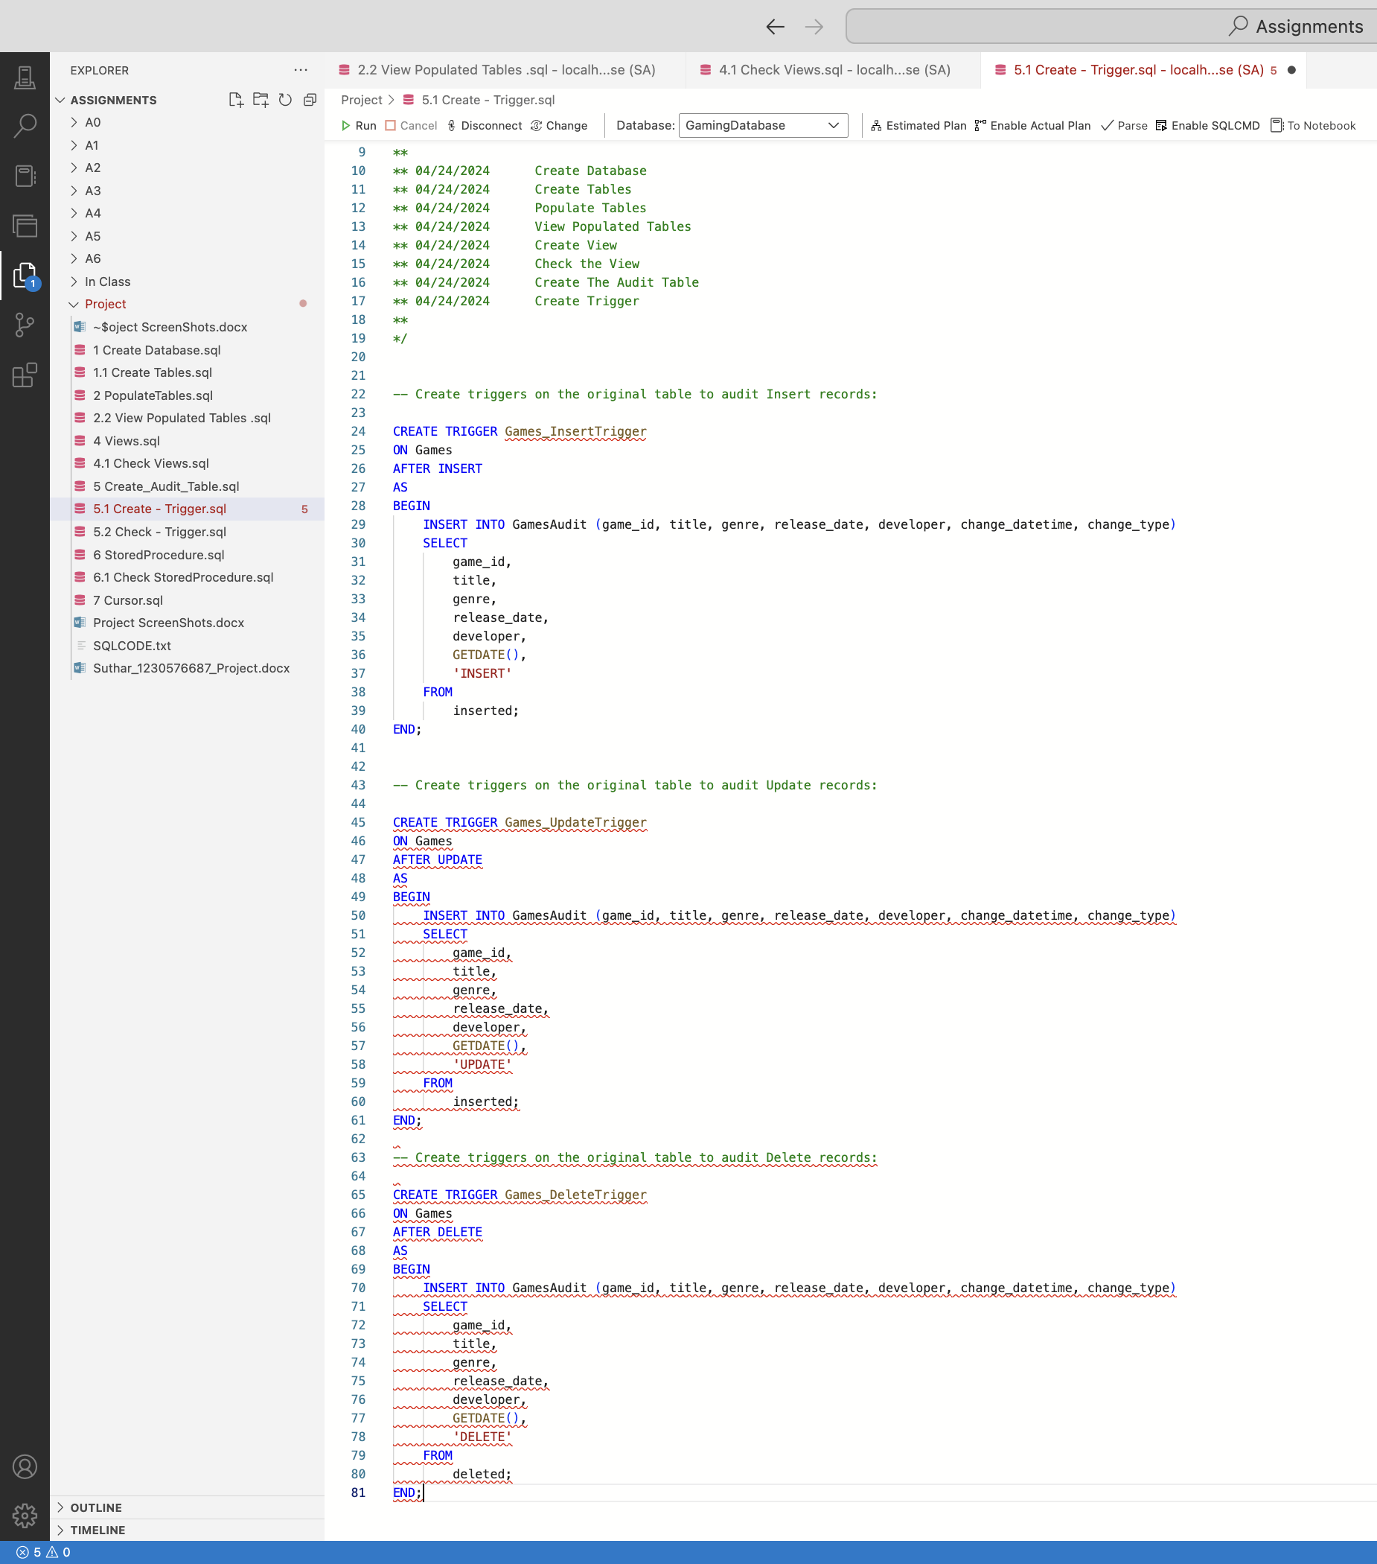 Fig: 18 Create trigger

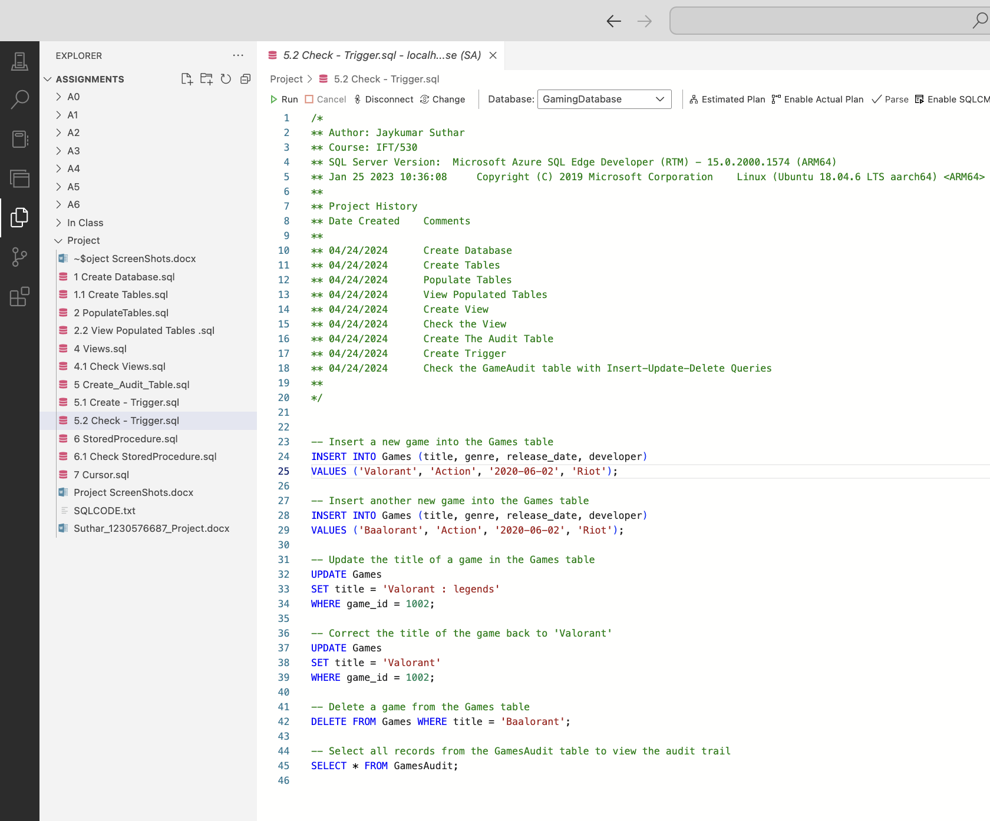 Fig: 18.1 Check trigger

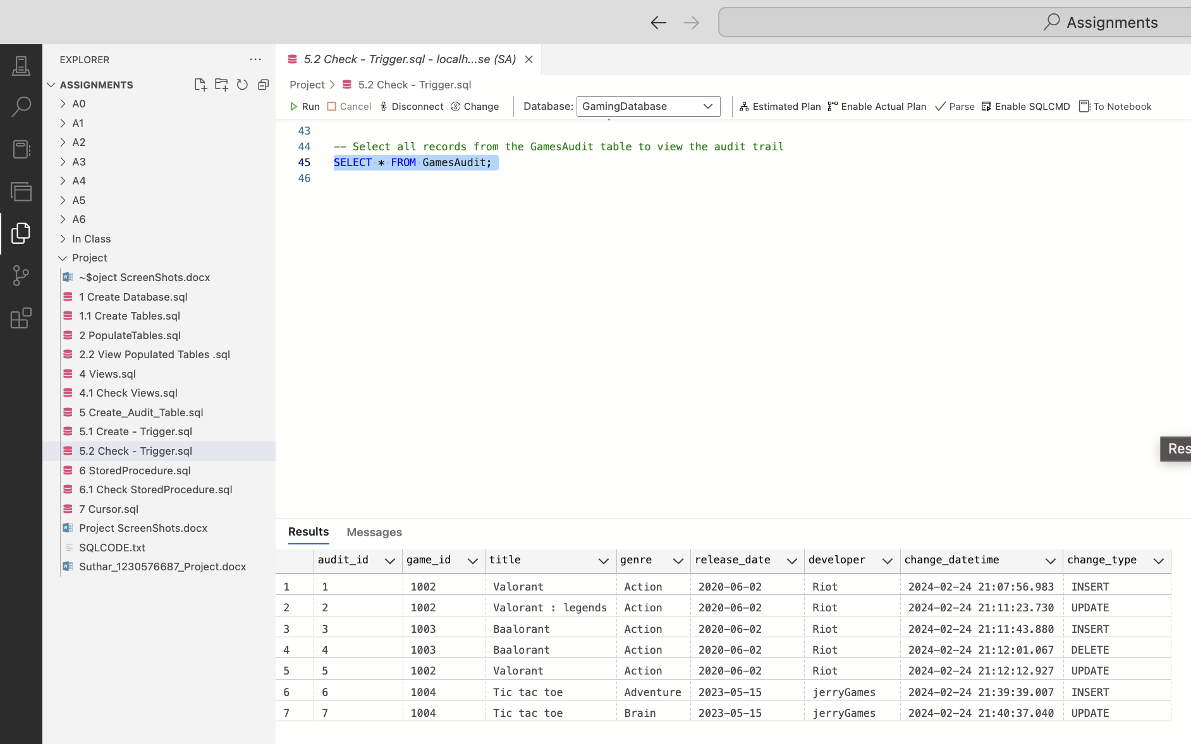 Fig: 18.2 Check Audit Table Output

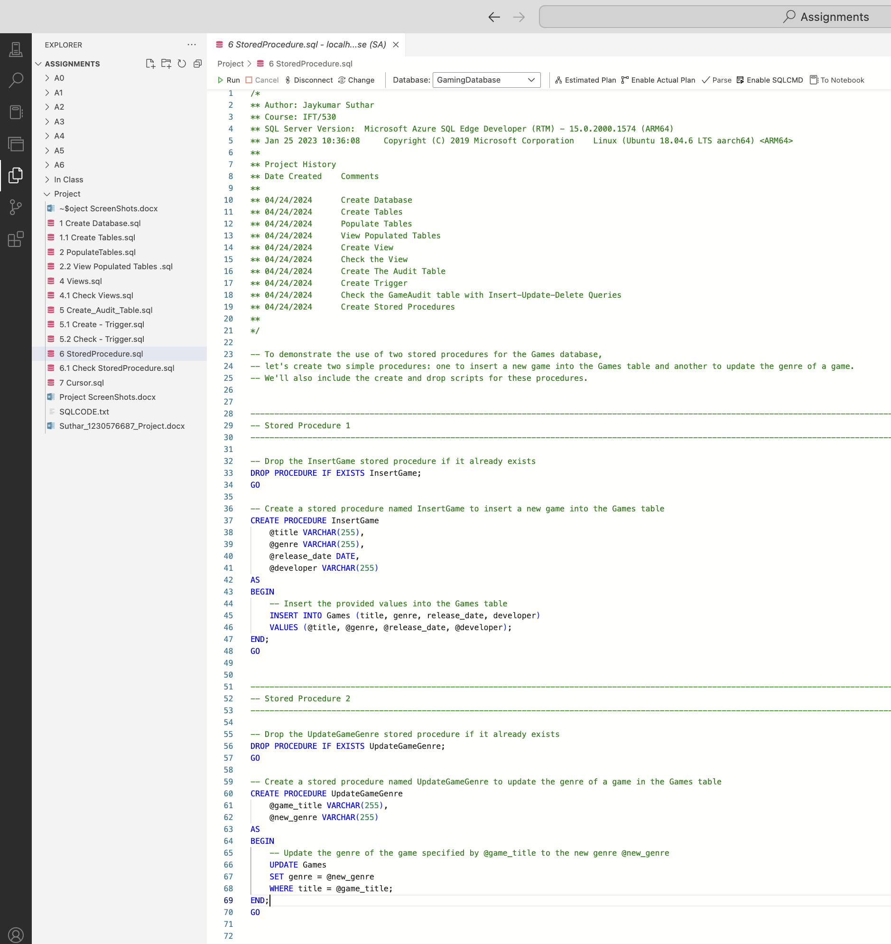 Fig: 19 Create Stored Procedure

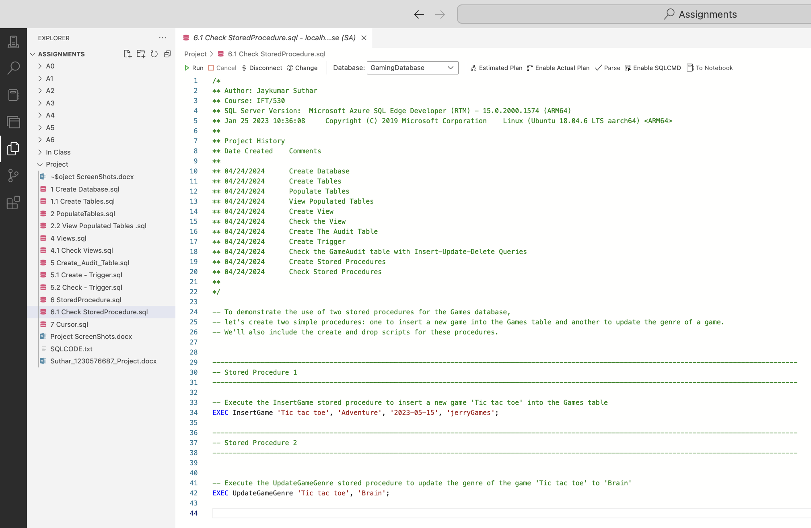 Fig: 19.1 Check Stored Procedure

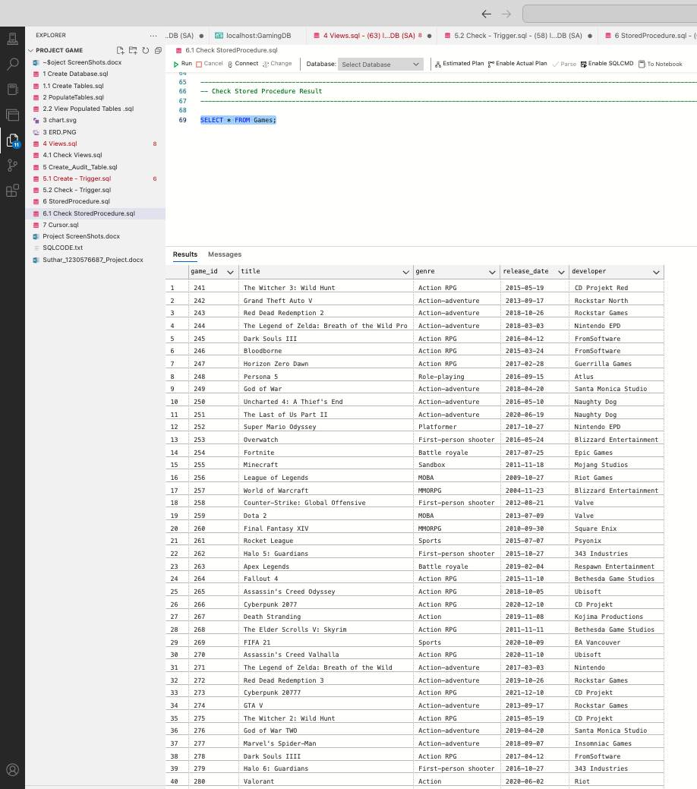 Fig: 19.2 Check Stored Procedure Output

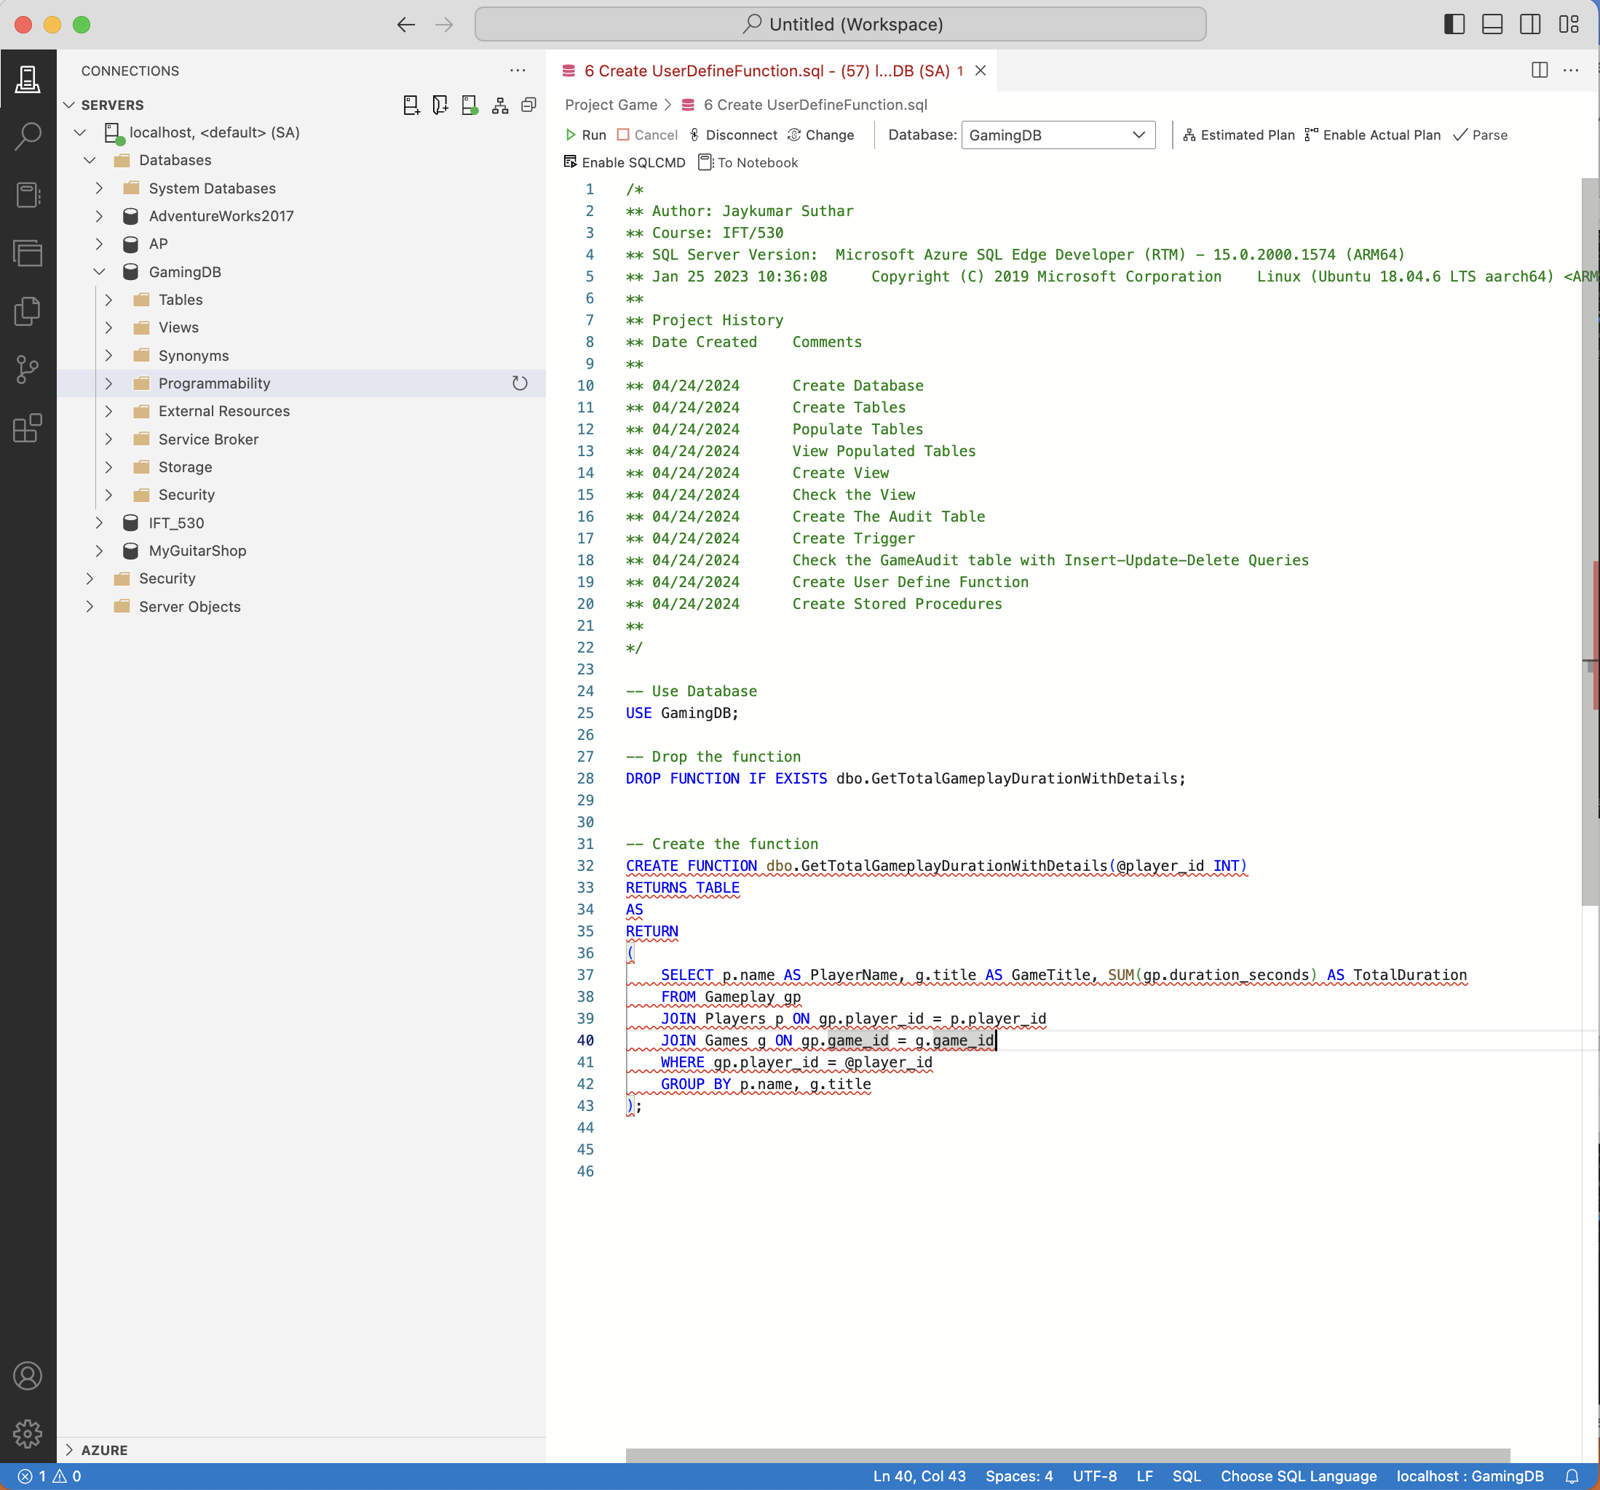 Fig: 20 Create User Define Function

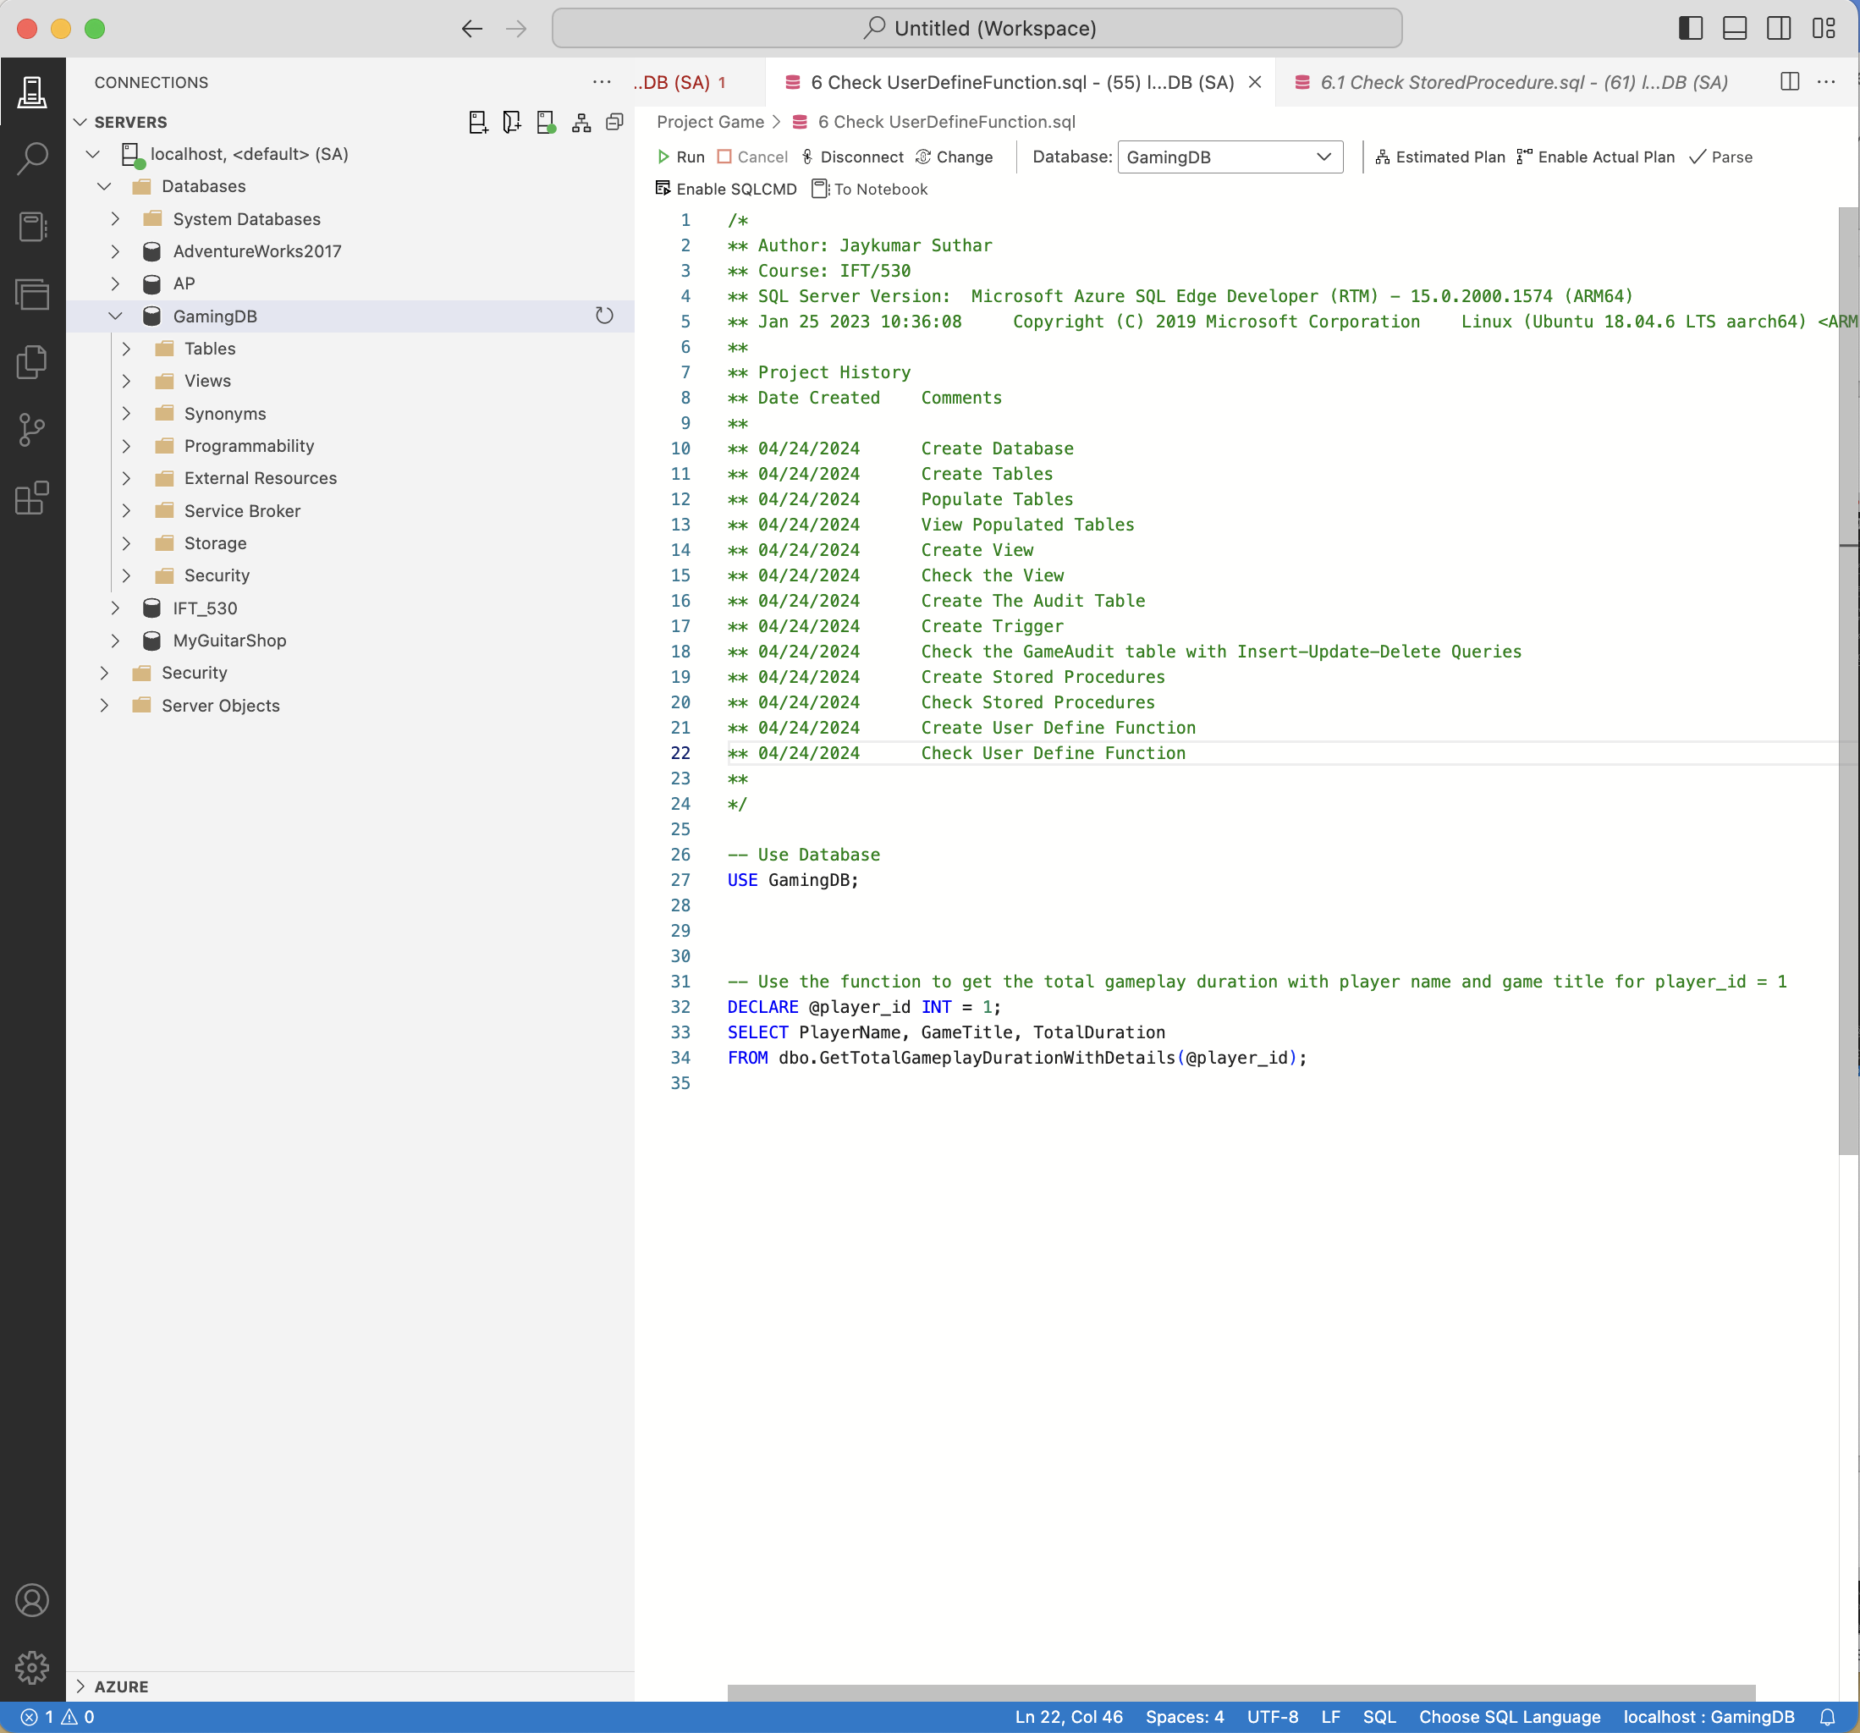 Fig: 20.1 Check User Define Function

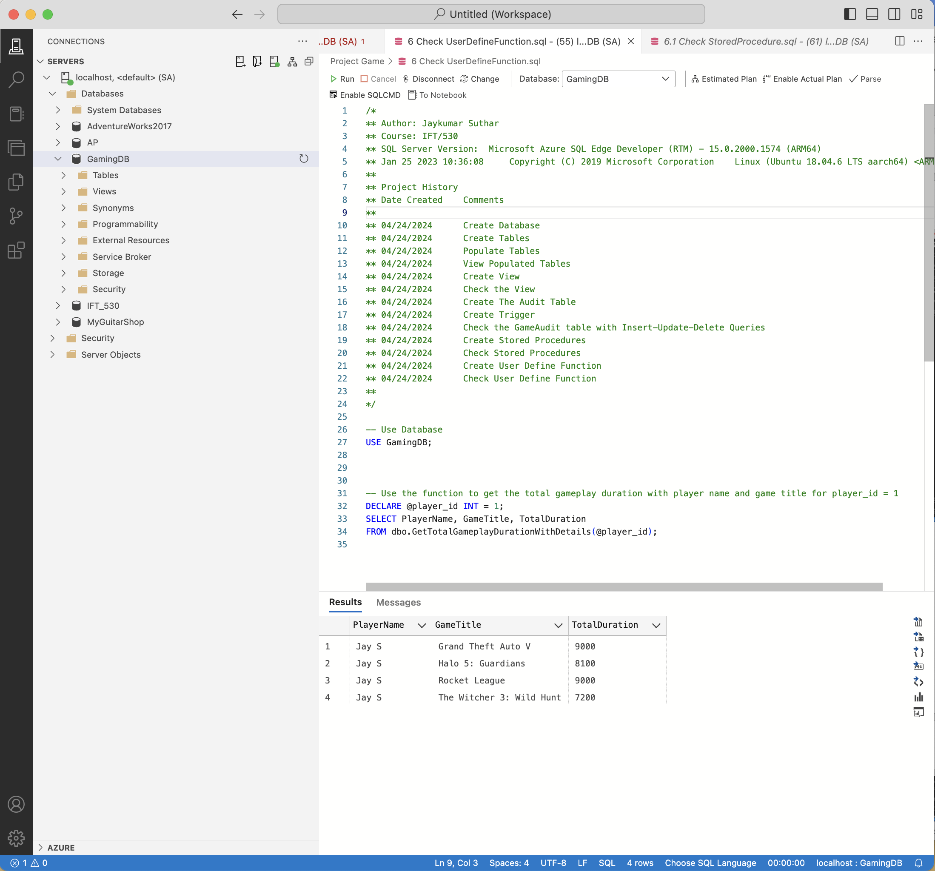 Fig: 20.2 Output - User Define Function

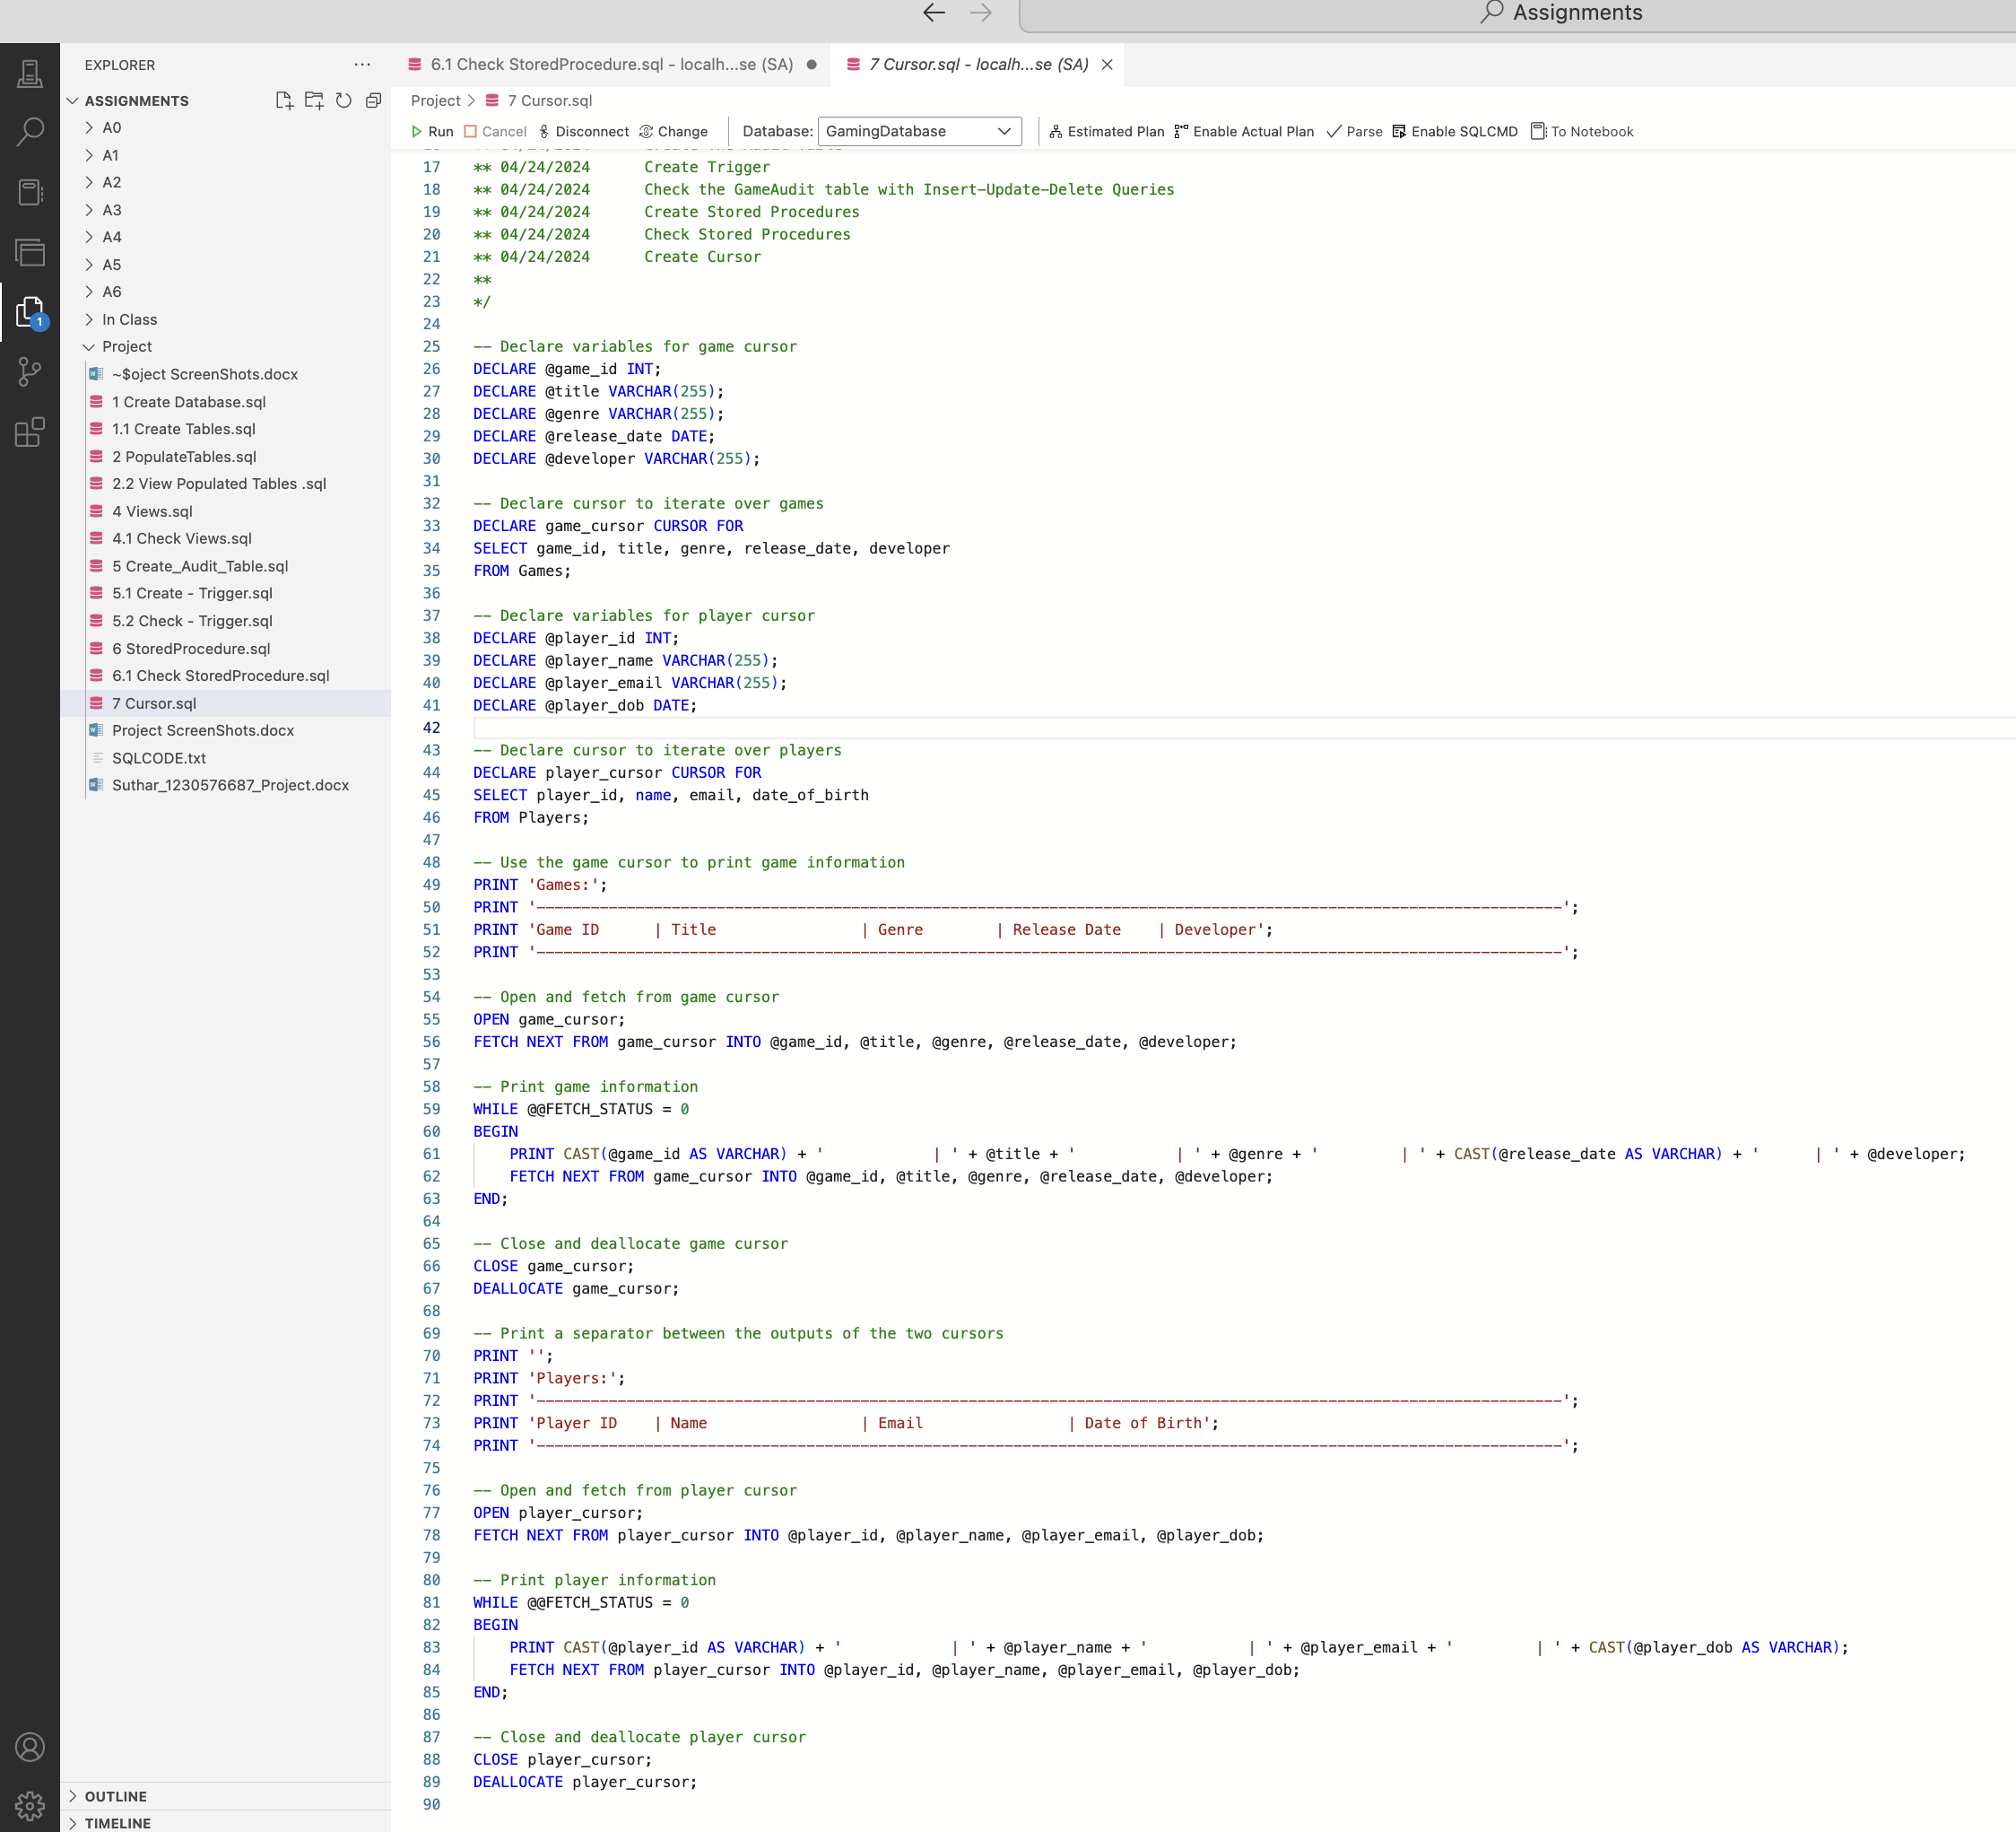

Fig: 21 Create Cursor

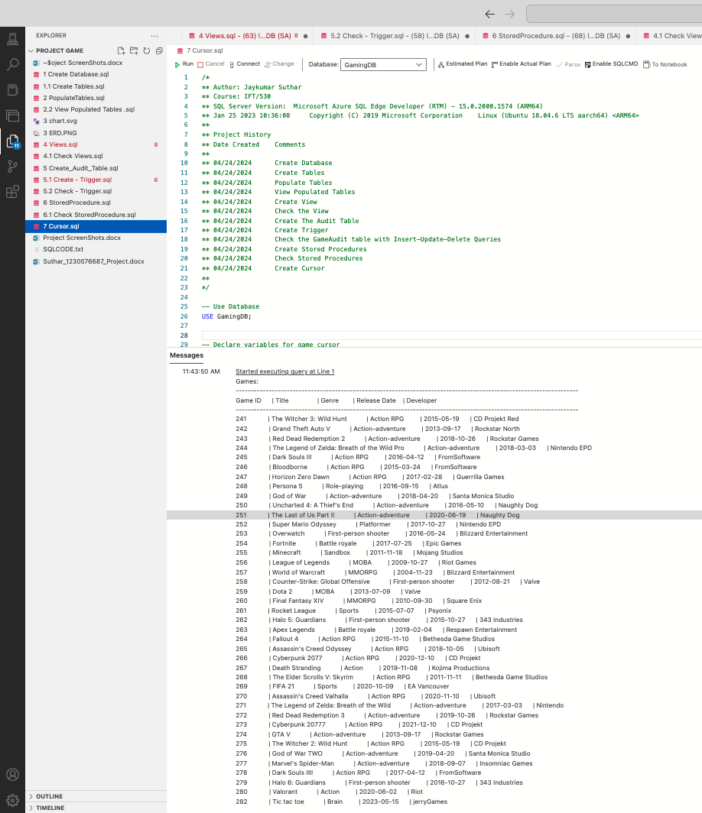

Fig: 21.1 Cursor Output

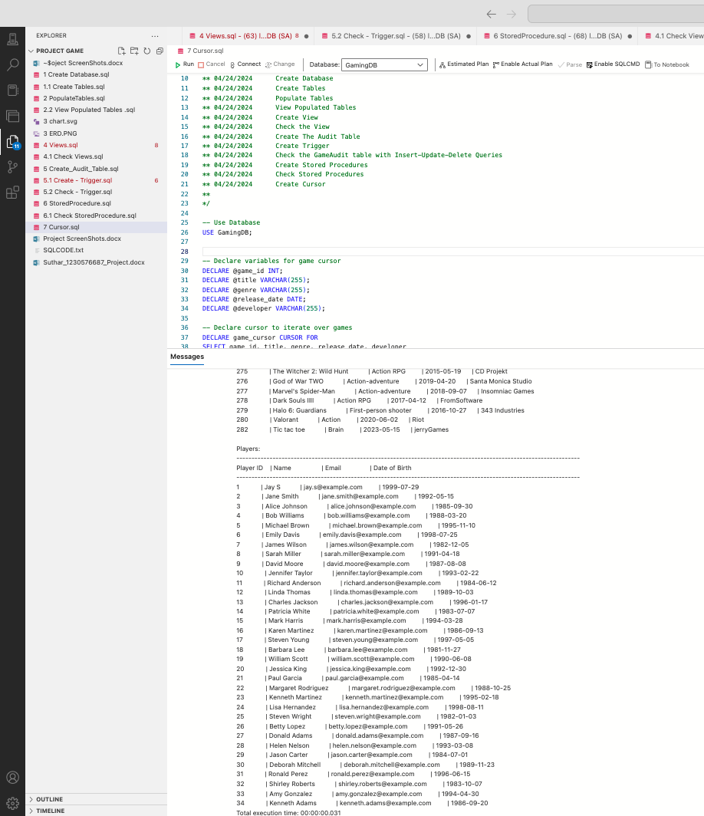

Fig: 21.3 Cursor Output cont.1